Supplementary Materials
These Supplementary Materials report the complete identification and robustness record behind the main text. The updated organization places modern staggered DID validation immediately after the data and support audit, followed by the previously executed local projection, first difference, cohort robust, clean control, PPMLHDFE, mechanism, spatial, and reproducibility analyses. The modern section explicitly distinguishes the preferred conditional imputation estimator from unconditional group time ATT and conventional TWFE, so estimator specific pretreatment behavior remains visible. All level based event study figures use the prespecified event time −5 to +5 reporting window with −1 omitted whenever the estimator supports that window. The first difference event study uses −4 to +5 because annual differencing requires one additional pretreatment observation. These window rules are applied uniformly to the modern and legacy dynamic diagnostics.
Supplementary A Data, treatment construction, and measurement
A1 Data sources and registry audit
County socioeconomic variables are drawn from the China County Statistical Yearbook database, prefecture level variables are drawn from the China City Statistical Yearbook database, and MPA locations, establishment timing, type, area, and administrative linkage are based on the Bh2021 marine protected area database used in the analysis. The executed workflow retains SHA 256 file digests and a variable level audit so the analytical inputs can be reproduced exactly.
Supplementary Table S1. Data and spatial linkage audit. The table verifies the coverage of the three source databases and the completeness of the MPA linkage fields used to assign county exposure. It supports the claim that all 357 county units used in spatial models have matched centroids and that the registry contains 322 unique MPAs.
Item | Value
County source rows | 69276
City source rows | 7426
MPA registry rows | 390
MPA rows | 390
unique sites | 322
rows with establishment year | 369
rows with area | 373
county links resolved | 377
county links unresolved | 13
expanded site rows | 80
county units | 357
centroid matched | 357
centroid missing | 0
boundary download errors | 3

A2 Original observations and ARIMA supplied values
Supplementary Table S2. Measurement coverage of the principal population outcomes. The table separates observations present in the original statistical yearbook worksheet from values supplied in the ARIMA completed worksheet. It motivates the observed year sensitivity analyses for variables with lower direct coverage.
outcome | share_observed_in_original_sheet | share_supplied_by_ARIMA_sheet
County year-end total population | 0.7721 | 0.2279
County rural population | 0.5286 | 0.4714
City resident population | 0.1193 | 0.8807

A3 Pretreatment covariate balance and common support
Supplementary Table S3. Full pretreatment balance audit. Standardized mean differences are reported before and after overlap weighting. The post weighting values are used as a diagnostic of observed baseline comparability and complement the Love plot reported in the main text.
variable | treated_mean | comparison_mean | SMD_unweighted | SMD_overlap_weighted
base_ln_gdp_pc_z | -0.0127 | -0.0209 | 0.0076 | 0.0028
base_primary_share_z | 0.2839 | -0.1176 | 0.2913 | 0.0429
base_tertiary_share_z | -0.0577 | 0.0214 | -0.0945 | -0.0851
base_ln_fiscal_pc_z | 0.1327 | -0.0075 | 0.1444 | 0.0038
base_ln_investment_pc_z | 0.1636 | 0.0154 | 0.1598 | 0.0005
base_ln_retail_pc_z | 0.0024 | 0.0072 | -0.0047 | -0.0003
base_beds_per_10k_z | -0.0064 | 0.0201 | -0.0267 | -0.0046
base_students_per_10k_z | -0.23 | -0.0129 | -0.2035 | -0.0056
base_rural_share_z | 0.1663 | -0.0228 | 0.1955 | 0.0058

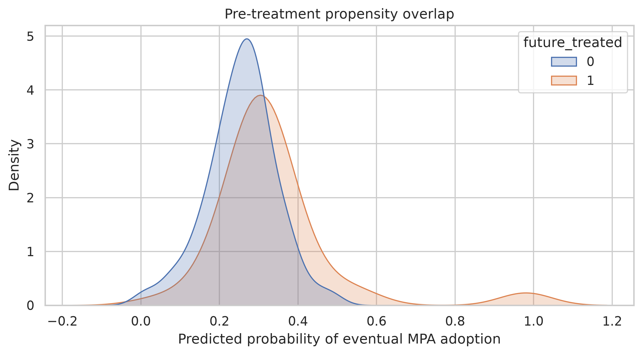
Supplementary Fig. S1. Pretreatment propensity overlap from the executed analysis. The distributions show that future treated and comparison counties share substantial common support in the estimated probability of eventual MPA adoption. This figure is a support diagnostic and does not substitute for the DID timing assumptions.
Supplementary B Modern staggered DID validation
B1 Estimator hierarchy and causal sample
The adoption based causal sample contains 281 county units, including 78 counties first treated from 2003 onward and 203 never treated counties. Modern staggered DID analysis separates three estimators. BJS imputation is the preferred conditional estimator because untreated outcomes are reconstructed using county fixed effects, province by year shocks, and baseline development trajectories. Clean group time ATT uses not yet treated controls and provides an unconditional comparison sensitivity. Conventional TWFE is reported only as a benchmark. The previously validated local projection DID remains a separate dynamic sensitivity.
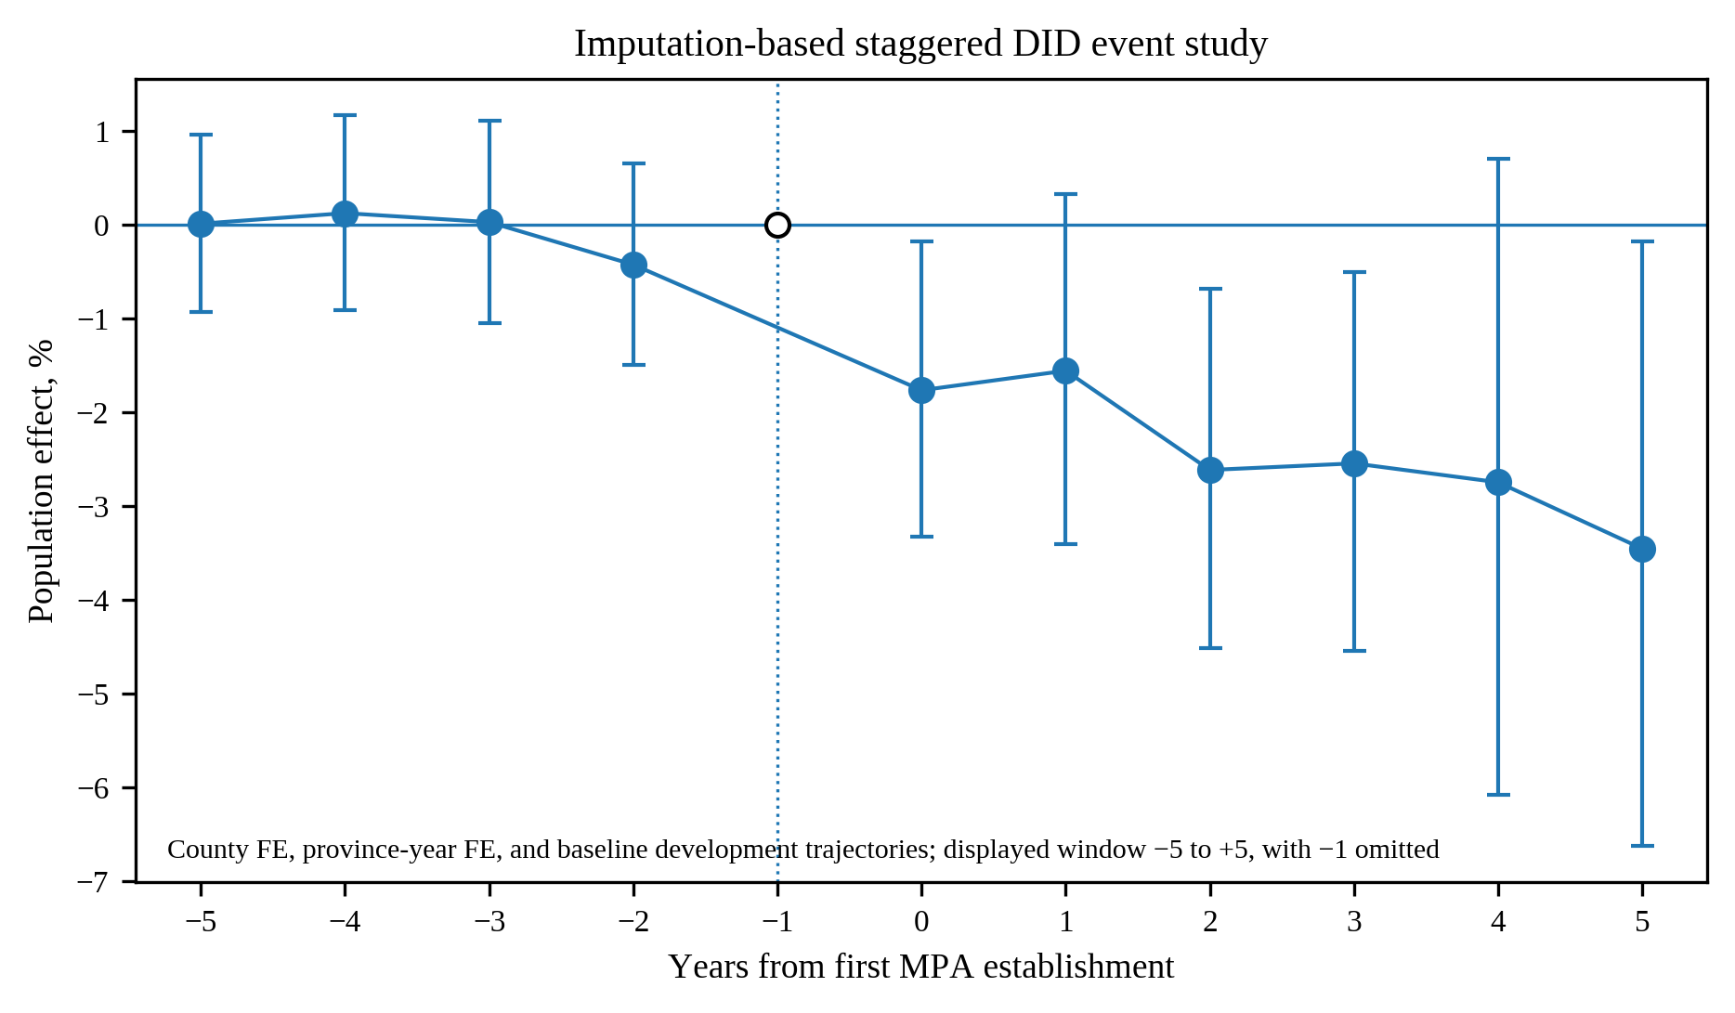
Supplementary Fig. S1a. Preferred imputation based staggered DID event study over the prespecified event time −5 to +5 window. Event time −1 is the omitted reference and is shown at zero. The four placebo leads from −5 through −2 are jointly indistinguishable from zero with p = 0.801. Population falls by 1.77% at establishment and 2.62% in year 2, with negative estimates at selected later horizons. Displaying every supported horizon in the common window makes the pretreatment diagnostic and post establishment path directly auditable.
Event time | Effect | 95% CI | p value | Counties
-5 | 0.009% | [-0.935, 0.962] | 0.9851 | 66
-4 | 0.121% | [-0.909, 1.163] | 0.8181 | 71
-3 | 0.026% | [-1.047, 1.110] | 0.9628 | 78
-2 | -0.428% | [-1.497, 0.652] | 0.4357 | 78
0 | -1.766% | [-3.326, -0.181] | 0.0291 | 78
1 | -1.559% | [-3.403, 0.321] | 0.1036 | 78
2 | -2.617% | [-4.514, -0.682] | 0.0082 | 78
3 | -2.546% | [-4.541, -0.510] | 0.0145 | 78
4 | -2.748% | [-6.076, 0.698] | 0.1168 | 78
5 | -3.456% | [-6.623, -0.181] | 0.0388 | 78
Supplementary Table S3a. Complete BJS imputation event estimates. The untreated outcome model is fit only on never treated observations and observations before county treatment, with county fixed effects, province by year fixed effects, and baseline characteristics interacted with linear and quadratic trends. The joint pretreatment Wald test over event times −5 to −2 gives p = 0.801.
B2 Clean group time ATT sensitivity
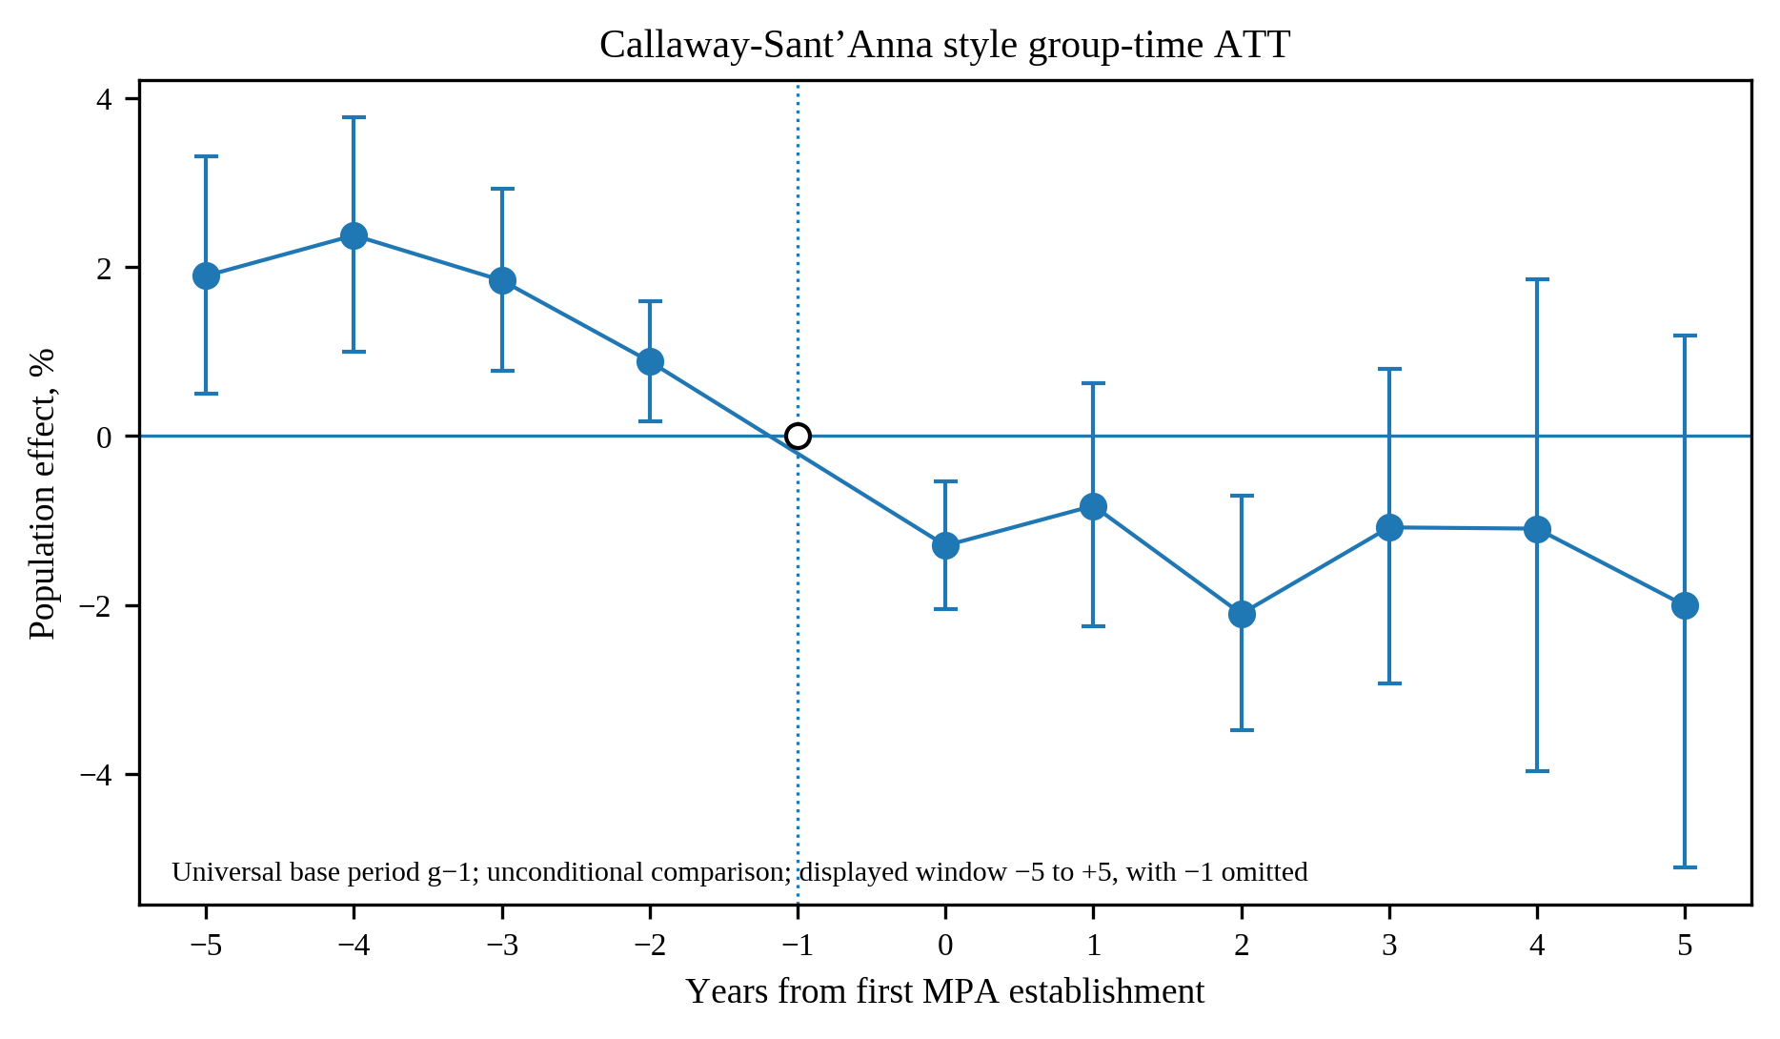
Supplementary Fig. S1b. Clean group time ATT event study using not yet treated controls and the universal event time −1 base, displayed over the same −5 to +5 window used for the preferred level event study. Post treatment magnitudes closely match the preferred estimator, with −1.30% at establishment and −2.11% in year 2. The four displayed pretreatment leads reject unconditional parallel trends jointly with p = 0.014, so this estimator is retained as a magnitude sensitivity rather than as the primary causal design.
Event time | Effect | 95% CI | p value | Cohorts | Treated weight
-5 | 1.898% | [0.501, 3.314] | 0.0076 | 8 | 62
-4 | 2.377% | [1.001, 3.772] | 0.0007 | 9 | 67
-3 | 1.842% | [0.771, 2.925] | 0.0007 | 10 | 74
-2 | 0.883% | [0.175, 1.596] | 0.0145 | 10 | 74
0 | -1.298% | [-2.051, -0.538] | 0.0008 | 10 | 74
1 | -0.826% | [-2.254, 0.622] | 0.2621 | 10 | 74
2 | -2.106% | [-3.486, -0.706] | 0.0033 | 10 | 74
3 | -1.082% | [-2.927, 0.798] | 0.2574 | 10 | 74
4 | -1.097% | [-3.966, 1.857] | 0.4626 | 10 | 74
5 | -2.007% | [-5.108, 1.195] | 0.2165 | 10 | 74
Supplementary Table S3b. Complete clean group time ATT estimates. Each cohort is compared with counties that are never treated or remain untreated through the relevant event year. The universal base placebo leads reject unconditional parallel trends, so these estimates do not replace the conditional imputation estimator.
B3 Cross estimator comparison
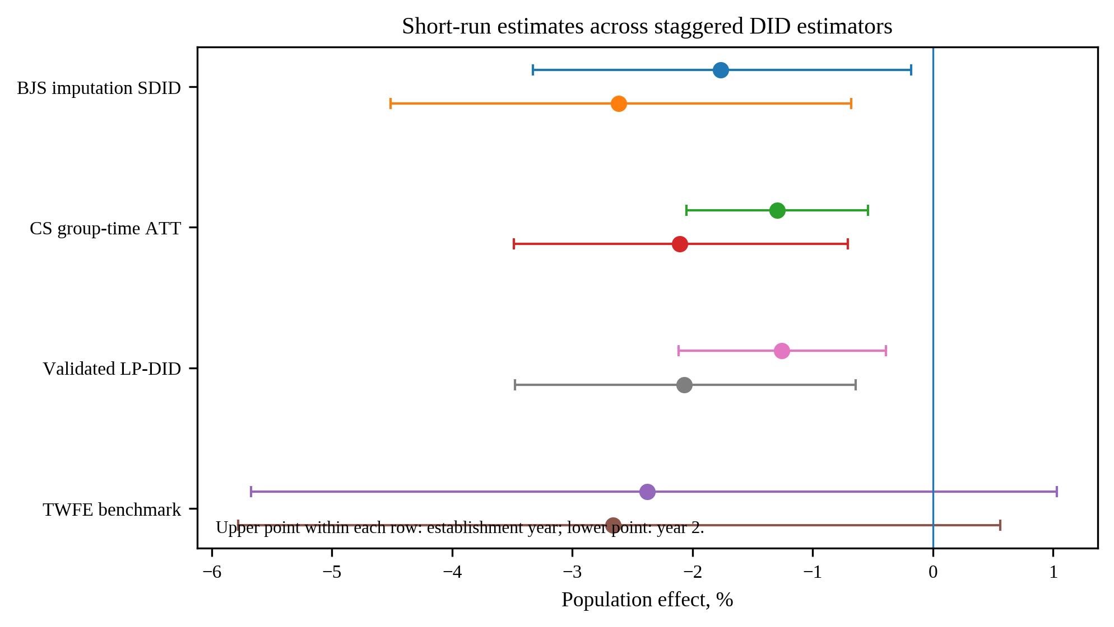
Supplementary Fig. S1c. Short term estimator comparison. BJS imputation, clean group time ATT, and validated local projection DID produce closely aligned negative effects at the establishment year and year 2. Traditional TWFE remains negative but its confidence intervals cross zero. The comparison shows why TWFE consistency is not treated as an identification requirement under staggered adoption.
Estimator | Horizon | Effect | 95% CI | p value | BH q
BJS imputation SDID | Establishment year | -1.766% | [-3.326, -0.181] | 0.0291 | 0.0291
BJS imputation SDID | Year 2 | -2.617% | [-4.514, -0.682] | 0.0082 | 0.0165
CS group-time ATT | Establishment year | -1.298% | [-2.051, -0.538] | 0.0008
CS group-time ATT | Year 2 | -2.106% | [-3.486, -0.706] | 0.0033
TWFE benchmark | Establishment year | -2.378% | [-5.671, 1.029] | 0.1690
TWFE benchmark | Year 2 | -2.660% | [-5.778, 0.561] | 0.1046
Validated LP-DID | Establishment year | -1.256% | [-2.114, -0.391] | 0.0047 | 0.0428
Validated LP-DID | Year 2 | -2.071% | [-3.479, -0.643] | 0.0048 | 0.0428
Supplementary Table S3c. Numerical comparison of the focused short term horizons across estimators. The preferred BJS estimates remain statistically resolved after BH adjustment within the two horizon family.
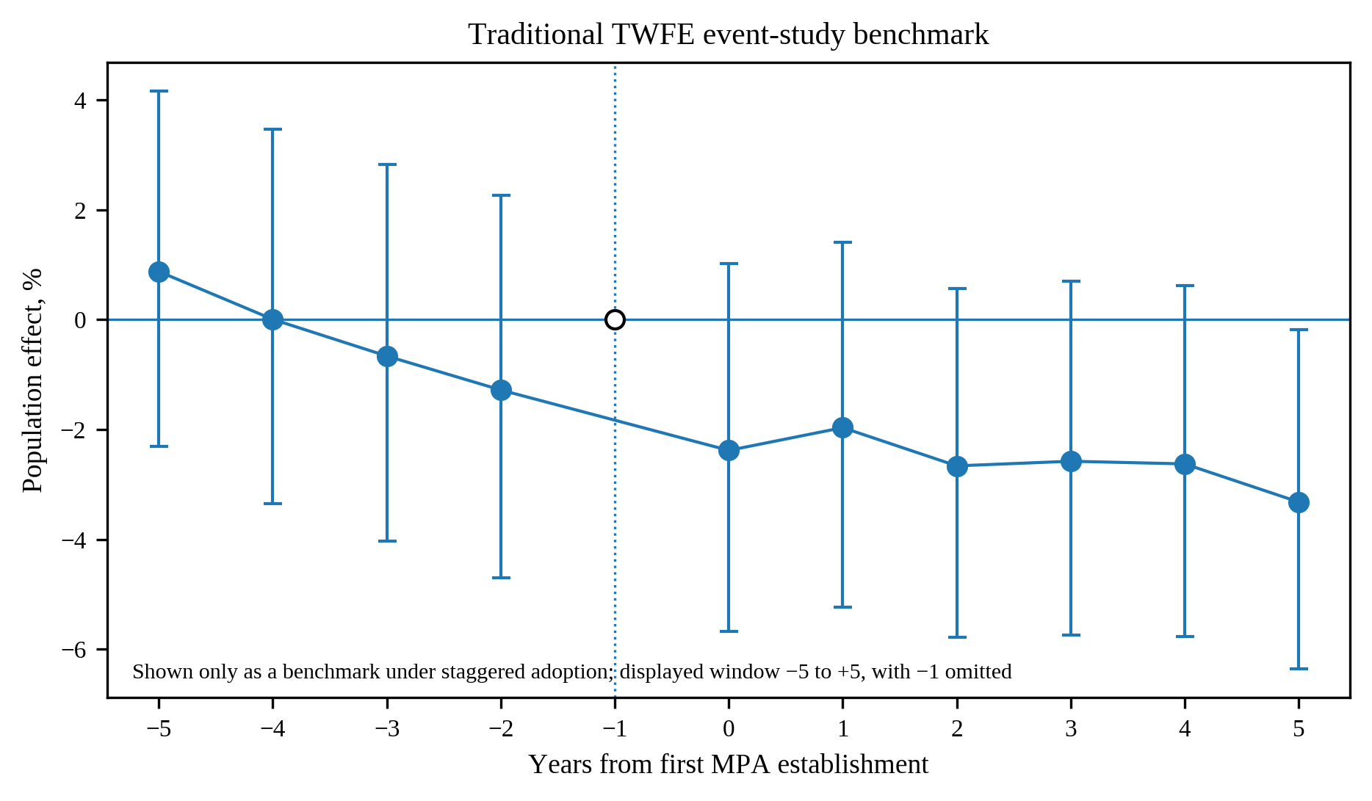
Supplementary Fig. S1d. Conventional TWFE event study benchmark over the prespecified −5 to +5 reporting window, with event time −1 omitted and shown at zero. The coefficients are provided for comparability only. They are less precise than the preferred modern estimator and are not used for causal interpretation because heterogeneous staggered timing can contaminate TWFE event coefficients through already treated comparisons.
B4 Conventional TWFE comparison weight decomposition
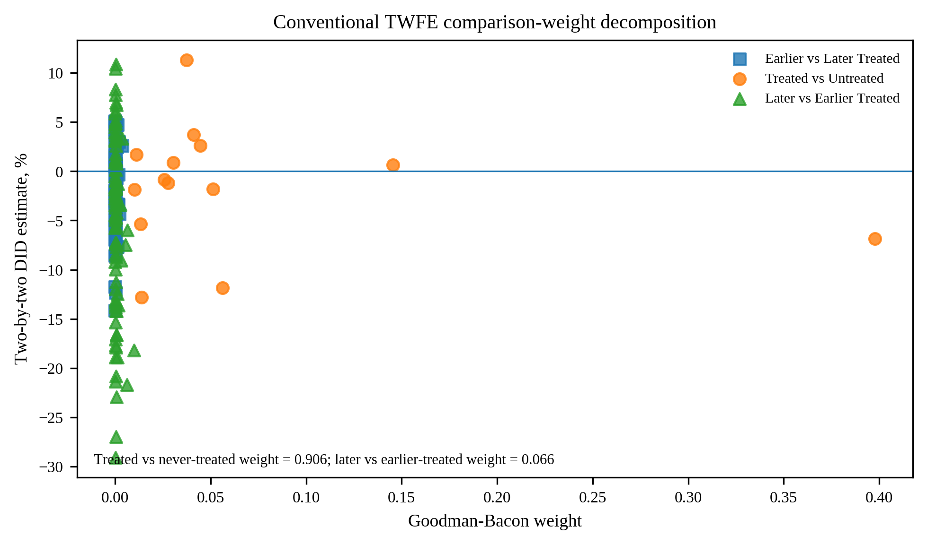
Supplementary Fig. S1e. Goodman-Bacon decomposition of the conventional static log-TWFE benchmark. The decomposition is diagnostic only and is not used as the preferred causal estimator. Treated versus never treated comparisons receive 90.58% of the total TWFE weight, earlier versus later treated comparisons receive 2.86%, and later versus earlier treated comparisons receive 6.56%. The last component is the comparison class in which already treated counties can serve as controls for later treated counties. Its nonzero weight motivates retaining TWFE as a benchmark while centering causal interpretation on modern staggered DID estimators.
Comparison type | TWFE weight | Weighted average DID | Comparisons
Earlier vs Later Treated | 2.86% | -1.105% | 91
Treated vs Untreated | 90.58% | -3.429% | 14
Later vs Earlier Treated | 6.56% | -9.897% | 91
Supplementary Table S3d. Goodman-Bacon summary of the conventional static log-TWFE benchmark. The decomposition exactly reconstructs the unit and year fixed effect TWFE coefficient. The relatively small later versus earlier treated weight limits, but does not eliminate, contamination from already treated comparison units; the modern estimators remain the basis for causal interpretation.
B5 Randomized timing falsification
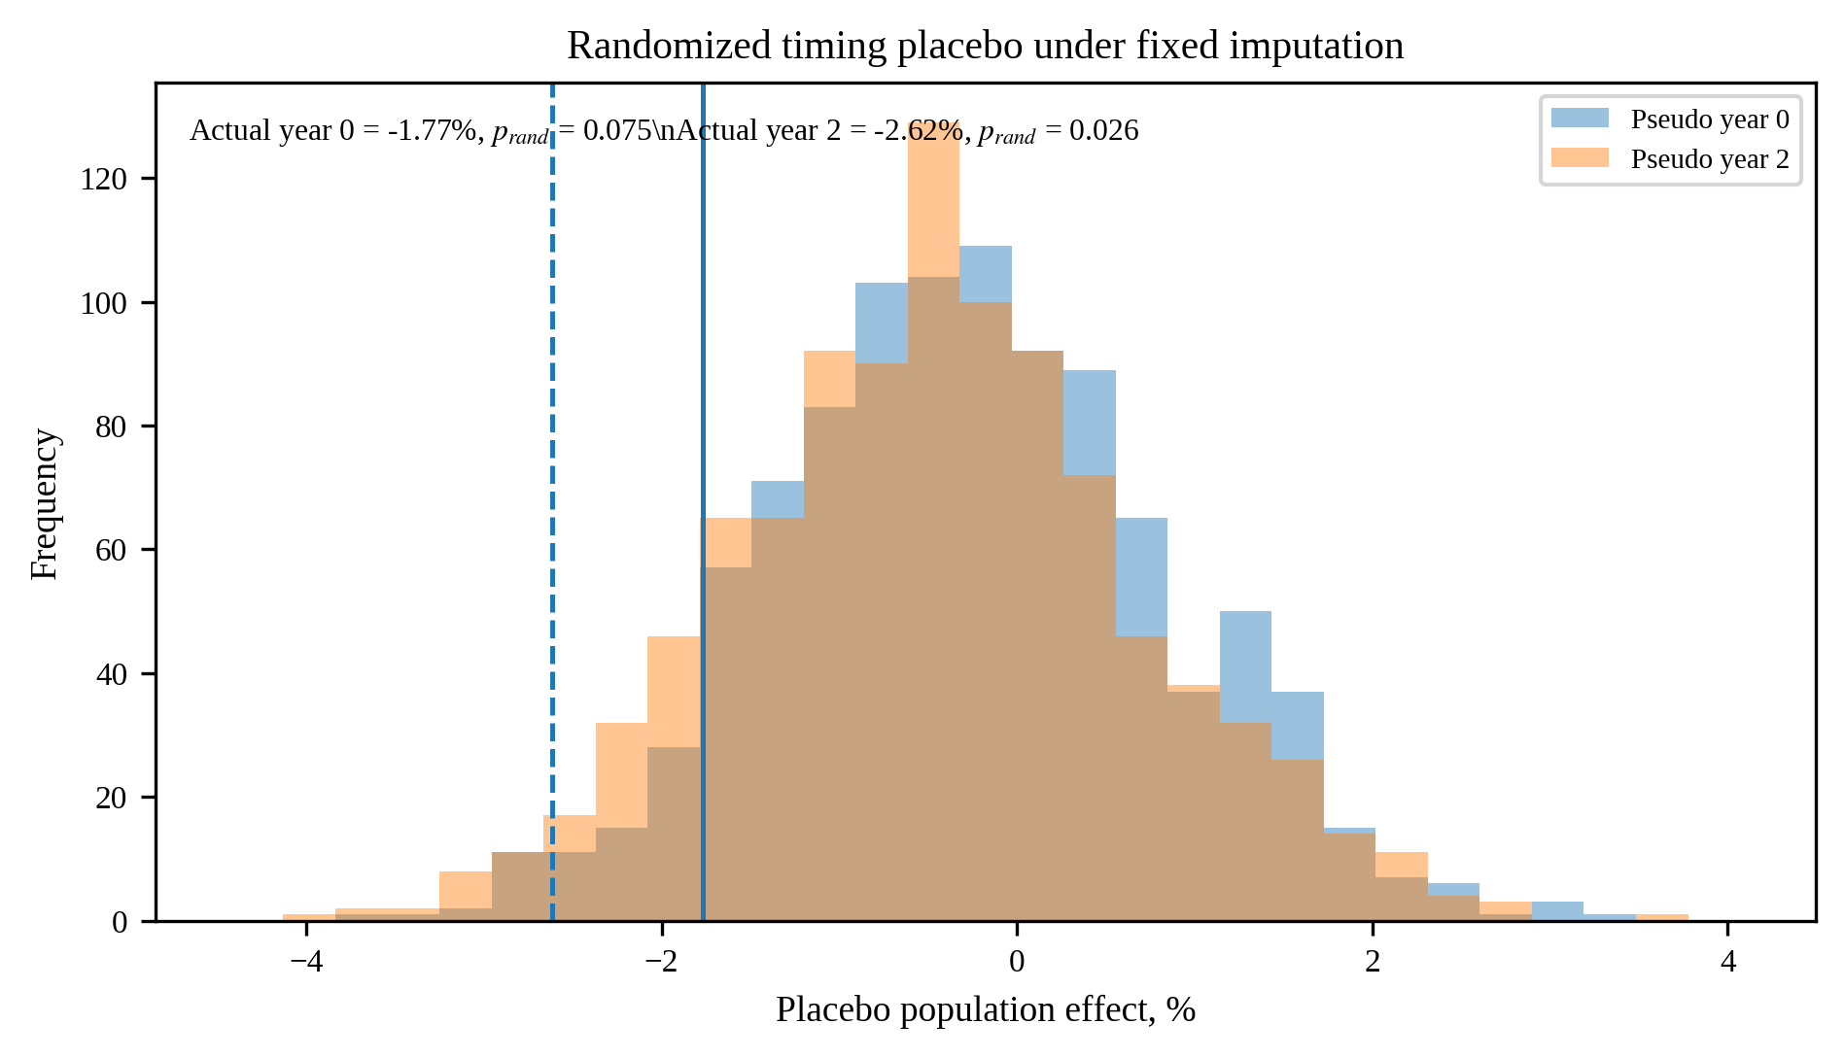
Supplementary Fig. S1f. Randomized treatment timing placebo under the fixed imputation model. Treatment cohort labels are shuffled across counties while preserving the cohort distribution. The actual year 2 estimate lies in the lower tail with one sided randomization p = 0.026. The establishment year estimate is less extreme, with p = 0.075. The placebo therefore strengthens the year 2 result while providing a more cautious falsification assessment for the immediate effect.
Diagnostic | Statistic | df | p value | Interpretation
BJS joint pretreatment Wald | 1.643869360839174 | 4.0 | 0.8009 | No joint evidence of residual pretreatment dynamics
CS universal-base joint pretreatment Wald | 12.475864034370256 | 4.0 | 0.0141 | Rejects unconditional parallel trends; CS retained as sensitivity
Validated first-difference joint pretreatment test | 0.489098 | 3.0 | 0.6898 | No joint evidence of differential annual changes
First-difference economic equivalence |  | 3.0 |  | All three 90% intervals lie within ±1%
Randomized timing placebo, establishment year |  |  | 0.0750 | One-sided randomization p
Randomized timing placebo, year 2 |  |  | 0.0260 | One-sided randomization p
Supplementary Table S3e. Modern staggered DID diagnostic summary. The table distinguishes the preferred conditional pretreatment test, the unconditional CS lead rejection, the independent first difference test, the economic equivalence criterion, and randomized timing falsification.
Supplementary C Complete identification diagnostics
C1 Full local projection DID window
The previously validated local projection DID is retained as a dynamic sensitivity to the preferred modern staggered DID estimator. The complete horizon is reported here so the earlier result remains auditable and can be compared with Supplementary Section B.
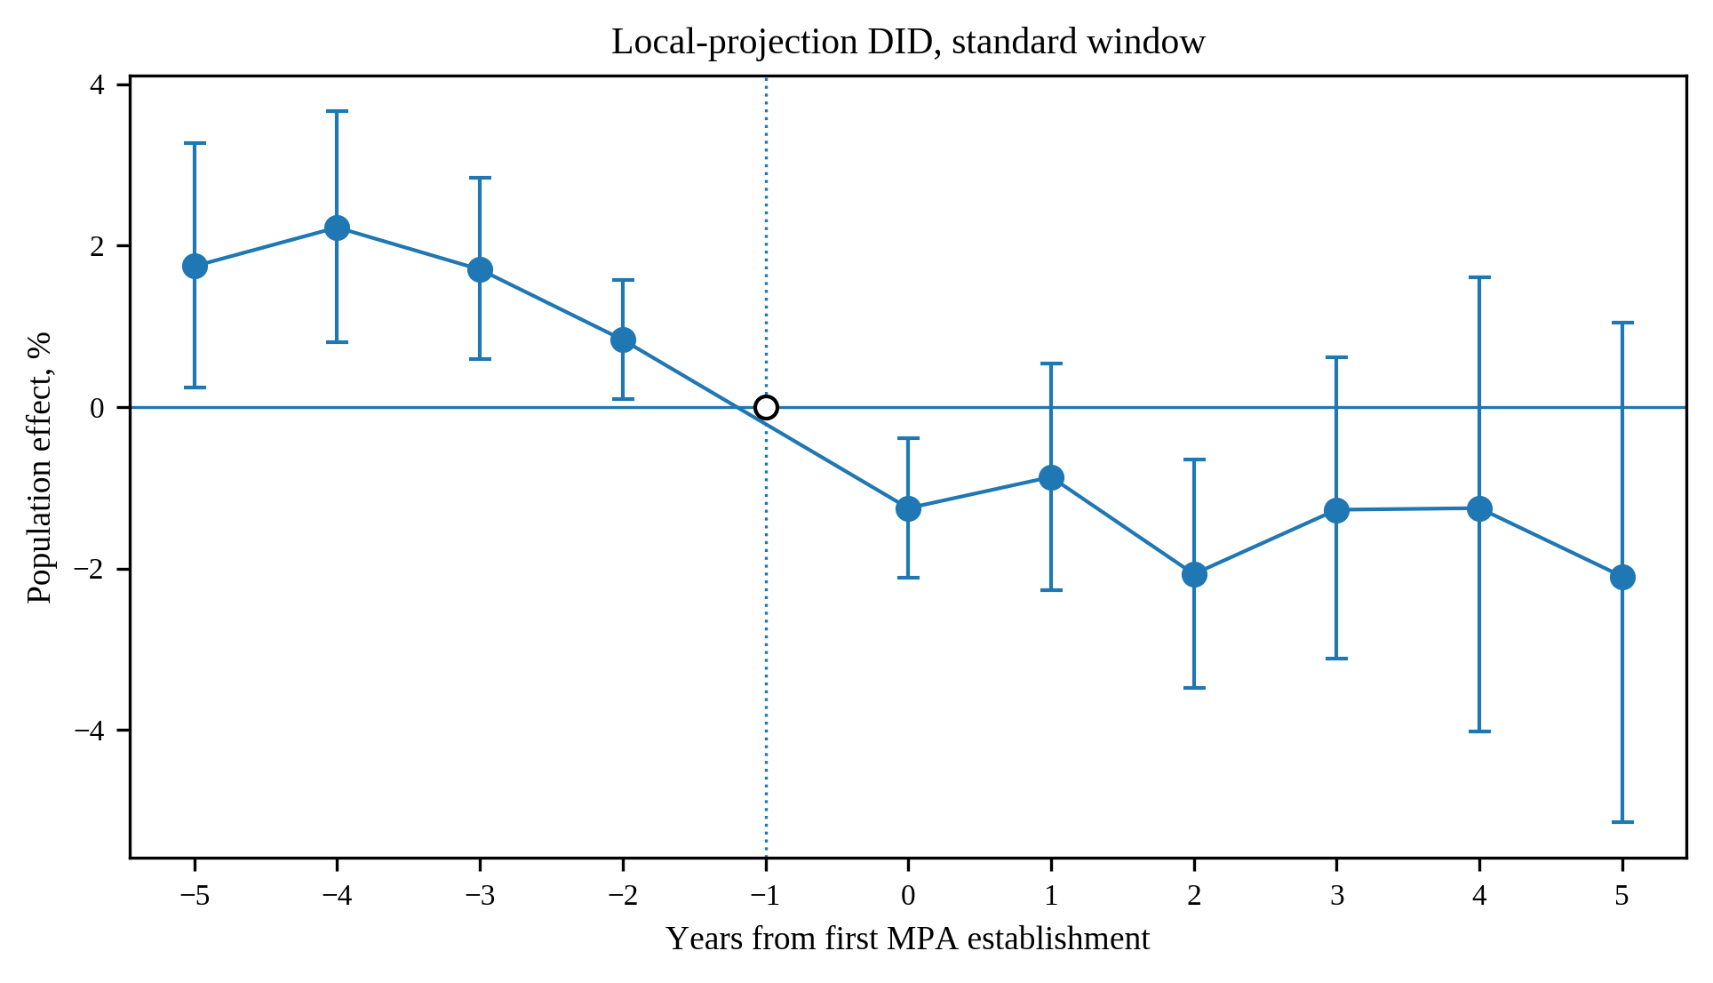
Supplementary Fig. S2. Local projection DID over the prespecified event time −5 to +5 window, with event time −1 shown as the reference. Every estimated horizon in the common reporting window is displayed. Establishment and year 2 remain the prespecified confirmatory horizons, while the remaining coefficients document the broader dynamic path without selective omission.
Supplementary Table S4. Full local projection DID estimates. The complete coefficient path provides the numerical counterpart to Supplementary Fig. S2 and makes the horizon specific sample size and uncertainty auditable.
Event time | Log estimate | CI low | CI high | p value | N
-5 | 0.0173 | 0.0024 | 0.0322 | 0.0229 | 4442.0
-4 | 0.022 | 0.008 | 0.036 | 0.0022 | 4716.0
-3 | 0.0169 | 0.0059 | 0.028 | 0.0028 | 4997.0
-2 | 0.0083 | 0.001 | 0.0156 | 0.0261 | 5278.0
0 | -0.0126 | -0.0214 | -0.0039 | 0.0047 | 5559.0
1 | -0.0087 | -0.0229 | 0.0054 | 0.225 | 5278.0
2 | -0.0209 | -0.0354 | -0.0065 | 0.0048 | 4997.0
3 | -0.0128 | -0.0317 | 0.0061 | 0.184 | 4723.0
4 | -0.0126 | -0.041 | 0.0159 | 0.3848 | 4454.0
5 | -0.0212 | -0.0528 | 0.0104 | 0.1874 | 4190.0

C2 Full first difference event study and equivalence diagnostic
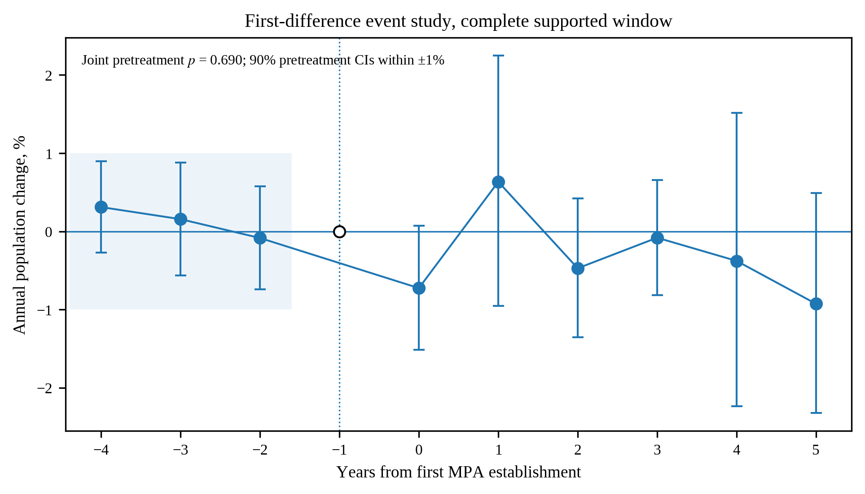
Supplementary Fig. S3. Complete supported first difference event study from event time −4 through +5, with −1 shown as the omitted reference. The lead window begins at −4 because annual differencing requires one additional observation before the indexed event year. The joint pretreatment test is p = 0.690, and the three pretreatment 90% intervals lie within the prespecified ±1% equivalence bound. Post establishment annual changes are displayed for transparency and do not replace the level based staggered DID estimand.
Supplementary Table S5. First difference estimates, joint pretreatment tests, and equivalence bounds. The total population pretreatment joint test has p = 0.6898, and all three 90% intervals fall inside the prespecified one percent equivalence bound, which strengthens the parallel trends assessment beyond a failure to reject zero.
outcome | event_time | Effect, % | CI low, % | CI high, % | p value
pop_total | -4 | 0.3112 | -0.2713 | 0.8971 | 0.2944
pop_total | -3 | 0.1567 | -0.5623 | 0.8809 | 0.6691
pop_total | -2 | -0.0842 | -0.739 | 0.5748 | 0.8009
pop_total | 0 | -0.7247 | -1.516 | 0.073 | 0.0747
pop_total | 1 | 0.6348 | -0.9526 | 2.2477 | 0.434
pop_total | 2 | -0.4711 | -1.3545 | 0.4201 | 0.2979
pop_total | 3 | -0.0804 | -0.8121 | 0.6568 | 0.8296
pop_total | 4 | -0.3767 | -2.2359 | 1.5178 | 0.6936
pop_total | 5 | -0.9252 | -2.3223 | 0.4919 | 0.1987
pop_rural | -4 | -1.3022 | -2.9626 | 0.3867 | 0.1294
pop_rural | -3 | 1.1198 | -0.5755 | 2.8439 | 0.1958
pop_rural | -2 | -0.1086 | -1.5442 | 1.3479 | 0.8826
pop_rural | 0 | 0.0042 | -1.2254 | 1.249 | 0.9947
pop_rural | 1 | -0.8848 | -2.0858 | 0.3309 | 0.1523
pop_rural | 2 | 0.0977 | -1.784 | 2.0154 | 0.9194
pop_rural | 3 | -0.7811 | -1.3924 | -0.1659 | 0.0131
pop_rural | 4 | -1.6706 | -3.4949 | 0.1881 | 0.0776
pop_rural | 5 | -0.7524 | -1.3094 | -0.1924 | 0.0087
rural income × rurality | -4 | 1.4071 | 0.1813 | 2.6479 | 0.0245
rural income × rurality | -3 | -0.4598 | -1.4504 | 0.5407 | 0.3647
rural income × rurality | -2 | -1.0395 | -1.8537 | -0.2186 | 0.0134
rural income × rurality | 0 | -1.4407 | -2.3023 | -0.5715 | 0.0013
rural income × rurality | 1 | 0.0883 | -1.5583 | 1.7624 | 0.9166
rural income × rurality | 2 | -2.8779 | -8.7728 | 3.3978 | 0.3589
rural income × rurality | 3 | 0.7469 | -1.6874 | 3.2414 | 0.5493
rural income × rurality | 4 | -3.0697 | -4.9691 | -1.1324 | 0.0022
rural income × rurality | 5 | -1.0321 | -2.7459 | 0.7119 | 0.243

test | terms | wald_F | p | available_terms
Joint pretrend, pop_total | fd_m4, fd_m3, fd_m2 | 0.4891 | 0.6898 | 3
Joint pretrend, pop_rural | fd_m4, fd_m3, fd_m2 | 0.9602 | 0.4104 | 3
Joint pretrend, rural income interaction | fd_m4:base_rural_share_z, fd_m3:base_rural_share_z, fd_m2:base_rural_share_z | 2.9144 | 0.0329 | 3

outcome | event_time | equivalence_bound_percent | ci90_low_percent | ci90_high_percent | economically_small
pop_total | -4 | 1.0 | -0.1758 | 0.7973 | True
pop_total | -3 | 1.0 | -0.4454 | 0.7585 | True
pop_total | -2 | 1.0 | -0.6336 | 0.465 | True
pop_rural | -4 | 1.0 | -2.7282 | 0.1068 | False
pop_rural | -3 | 1.0 | -0.2989 | 2.526 | False
pop_rural | -2 | 1.0 | -1.318 | 1.1007 | False
rural income × rurality | -4 | 1.5 | 0.3825 | 2.4121 | False
rural income × rurality | -3 | 1.5 | -1.2954 | 0.3736 | True
rural income × rurality | -2 | 1.5 | -1.7343 | -0.3557 | False

C3 Cohort robust saturated event study
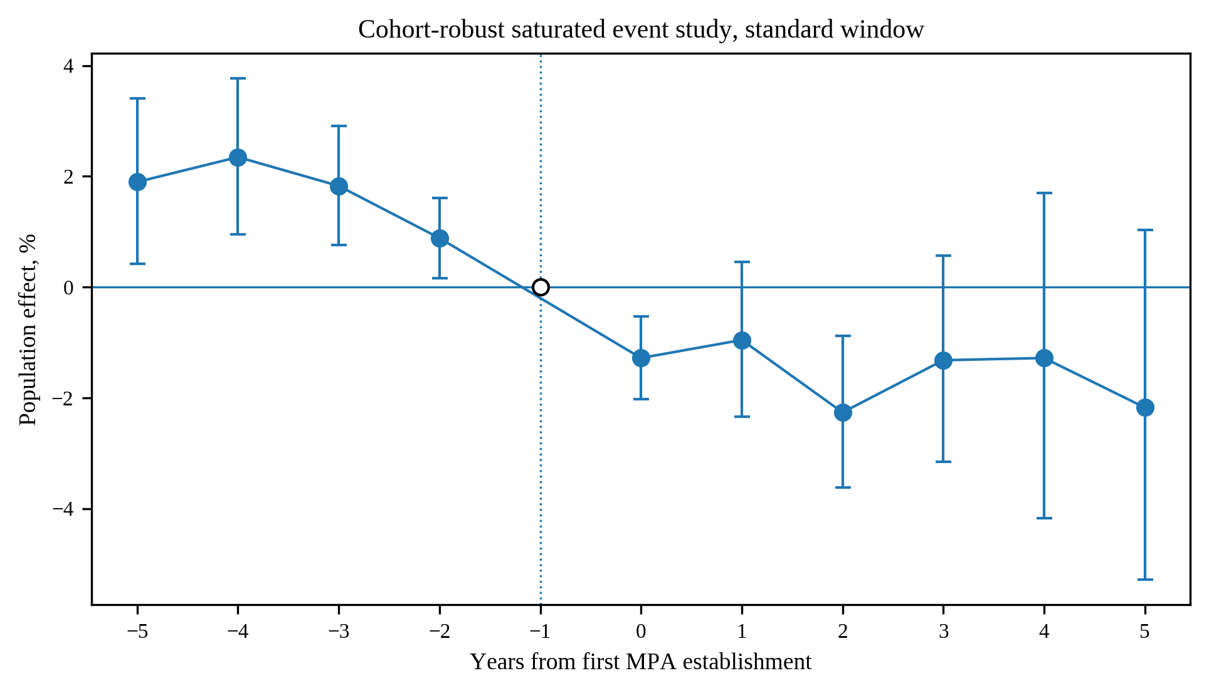
Supplementary Fig. S4. Cohort robust saturated event study restricted to the same prespecified event time −5 to +5 window used for the modern level event studies. Event time −1 is the omitted reference and is shown at zero. The estimator allows event effects to vary across treatment cohorts and remains a demanding sensitivity because several pretreatment coefficients are distinguishable from zero. Restricting the display to the common window prevents long tail cohorts with changing composition from dominating visual interpretation.
Supplementary Table S6. Complete cohort robust event study. All available pre and post periods are reported so the timing sensitivity is visible rather than hidden by a narrow plotting window.
Event time | Estimate | 2.5% | 97.5% | p value
-19.0 | -0.0299 | -0.0732 | 0.0134 | 0.1754
-18.0 | -0.0177 | -0.0603 | 0.0249 | 0.4157
-17.0 | -0.0225 | -0.0637 | 0.0186 | 0.283
-16.0 | -0.0197 | -0.06 | 0.0207 | 0.3399
-15.0 | -0.0185 | -0.0597 | 0.0226 | 0.3775
-14.0 | 0.0056 | -0.0296 | 0.0408 | 0.7544
-13.0 | 0.0125 | -0.0195 | 0.0445 | 0.4438
-12.0 | 0.0179 | -0.0085 | 0.0443 | 0.1831
-11.0 | 0.0482 | -0.0242 | 0.1206 | 0.1923
-10.0 | 0.0309 | -0.0383 | 0.1001 | 0.3814
-9.0 | 0.0308 | -0.0236 | 0.0852 | 0.2669
-8.0 | 0.0305 | 0.0023 | 0.0587 | 0.0339
-7.0 | 0.0346 | 0.0119 | 0.0574 | 0.0029
-6.0 | 0.0293 | 0.0096 | 0.0491 | 0.0036
-5.0 | 0.0188 | 0.0042 | 0.0335 | 0.0114
-4.0 | 0.0232 | 0.0095 | 0.037 | 0.0009
-3.0 | 0.0181 | 0.0076 | 0.0287 | 0.0008
-2.0 | 0.0088 | 0.0016 | 0.0159 | 0.0162
0.0 | -0.0129 | -0.0205 | -0.0053 | 0.0009
1.0 | -0.0096 | -0.0237 | 0.0045 | 0.1836
2.0 | -0.0229 | -0.0369 | -0.0089 | 0.0014
3.0 | -0.0133 | -0.0321 | 0.0056 | 0.1675
4.0 | -0.0129 | -0.0426 | 0.0168 | 0.3942
5.0 | -0.022 | -0.0543 | 0.0103 | 0.1813
6.0 | -0.0154 | -0.0538 | 0.023 | 0.4315
7.0 | -0.0205 | -0.0605 | 0.0194 | 0.3134
8.0 | -0.0245 | -0.0693 | 0.0203 | 0.2834
9.0 | -0.0425 | -0.0898 | 0.0048 | 0.0784
10.0 | -0.0312 | -0.0855 | 0.0231 | 0.2605
11.0 | -0.0136 | -0.0744 | 0.0472 | 0.6613
12.0 | -0.0081 | -0.0758 | 0.0596 | 0.8139
13.0 | -0.0098 | -0.0839 | 0.0644 | 0.7961
14.0 | 0.0354 | -0.0489 | 0.1197 | 0.4107
15.0 | 0.0436 | -0.0426 | 0.1298 | 0.3218
16.0 | 0.0515 | -0.0431 | 0.1461 | 0.2863
17.0 | 0.0714 | -0.0451 | 0.1879 | 0.2296
18.0 | 0.1394 | -0.0045 | 0.2832 | 0.0576
19.0 | 0.1732 | 0.0073 | 0.339 | 0.0407
20.0 | 0.2383 | 0.0422 | 0.4344 | 0.0173
21.0 | 0.1728 | -0.0424 | 0.3881 | 0.1155

C4 Clean control stacked event study
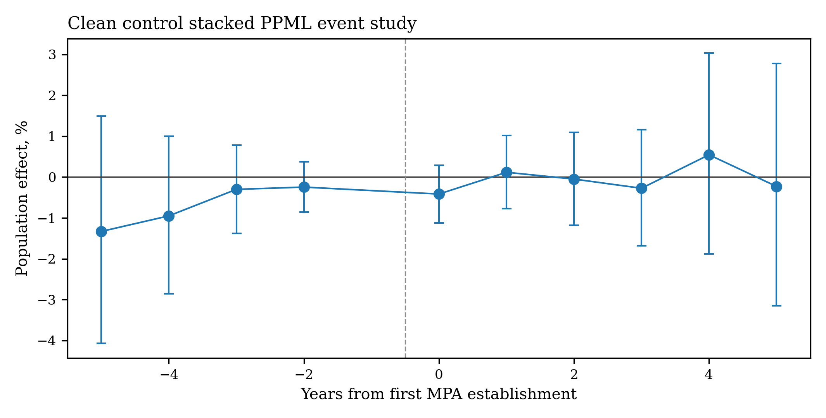
Supplementary Fig. S5. Clean control stacked PPML event study. Each treatment cohort is compared only with counties that remain untreated through the event window. Pretreatment coefficients are imprecise, while post treatment coefficients are also estimated with wider uncertainty. The figure demonstrates that stronger comparison group restrictions reduce contamination at the cost of precision. The displayed dynamic window is event time −5 through +5 with −1 omitted, matching the common level event study reporting convention.
Supplementary Table S7. Clean control stacked event coefficients and focused dynamic results. The table reports BH adjusted q values so the complete event family can be evaluated without relying on isolated nominal p values.
Event time | Effect, % | CI low, % | CI high, % | p value | BH q
-5 | -1.3306 | -4.0689 | 1.4859 | 0.3509 | 0.9317
-4 | -0.9499 | -2.8583 | 0.9959 | 0.3362 | 0.9317
-3 | -0.3017 | -1.3752 | 0.7835 | 0.5844 | 0.9317
-2 | -0.2459 | -0.8573 | 0.3692 | 0.4325 | 0.9317
0 | -0.416 | -1.1182 | 0.2912 | 0.2483 | 0.9317
1 | 0.1164 | -0.7737 | 1.0146 | 0.7984 | 0.9317
2 | -0.0498 | -1.1827 | 1.0961 | 0.9317 | 0.9317
3 | -0.2746 | -1.6834 | 1.1544 | 0.7048 | 0.9317
4 | 0.5446 | -1.883 | 3.0322 | 0.6632 | 0.9317
5 | -0.2294 | -3.1468 | 2.7759 | 0.8795 | 0.9317

Supplementary D Robustness and alternative specifications
D1 Static treatment definitions
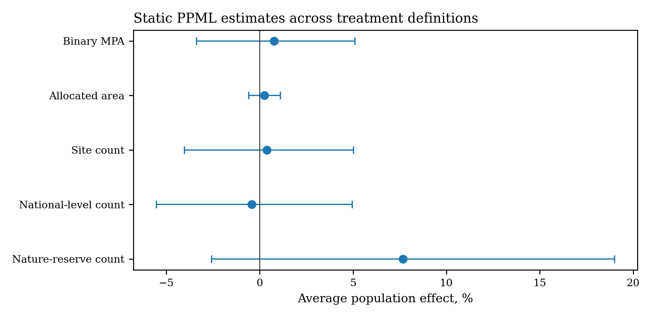
Supplementary Fig. S6. Static PPML estimates across alternative MPA exposure definitions. Binary establishment, site count, allocated area, national level sites, and nature reserve counts are all imprecise when averaged over the entire post establishment period. The figure reinforces the paper's focus on short term dynamics rather than a persistent average level effect.
Supplementary Table S8. Static PPML estimates across treatment definitions. This table provides the numerical basis for Supplementary Fig. S6 and shows that the pooled post establishment average does not reproduce the short term local projection effect.
model | term | estimate | SE | p | effect_% | CI_low_% | CI_high_%
Binary MPA | active_any | 0.0077 | 0.0215 | 0.7196 | 0.7745 | -3.3816 | 5.1094
Allocated area | ln1p_mpa_area_alloc | 0.0026 | 0.0043 | 0.549 | 0.2587 | -0.585 | 1.1095
Site count | ln1p_mpa_sites | 0.0039 | 0.023 | 0.8657 | 0.3897 | -4.0329 | 5.0161
National-level count | ln1p_national_sites | -0.0043 | 0.0268 | 0.8737 | -0.426 | -5.5304 | 4.9543
Nature-reserve count | ln1p_nature_sites | 0.0739 | 0.0511 | 0.1476 | 7.6739 | -2.5795 | 19.0065

D2 Controls, fixed effects, and inference
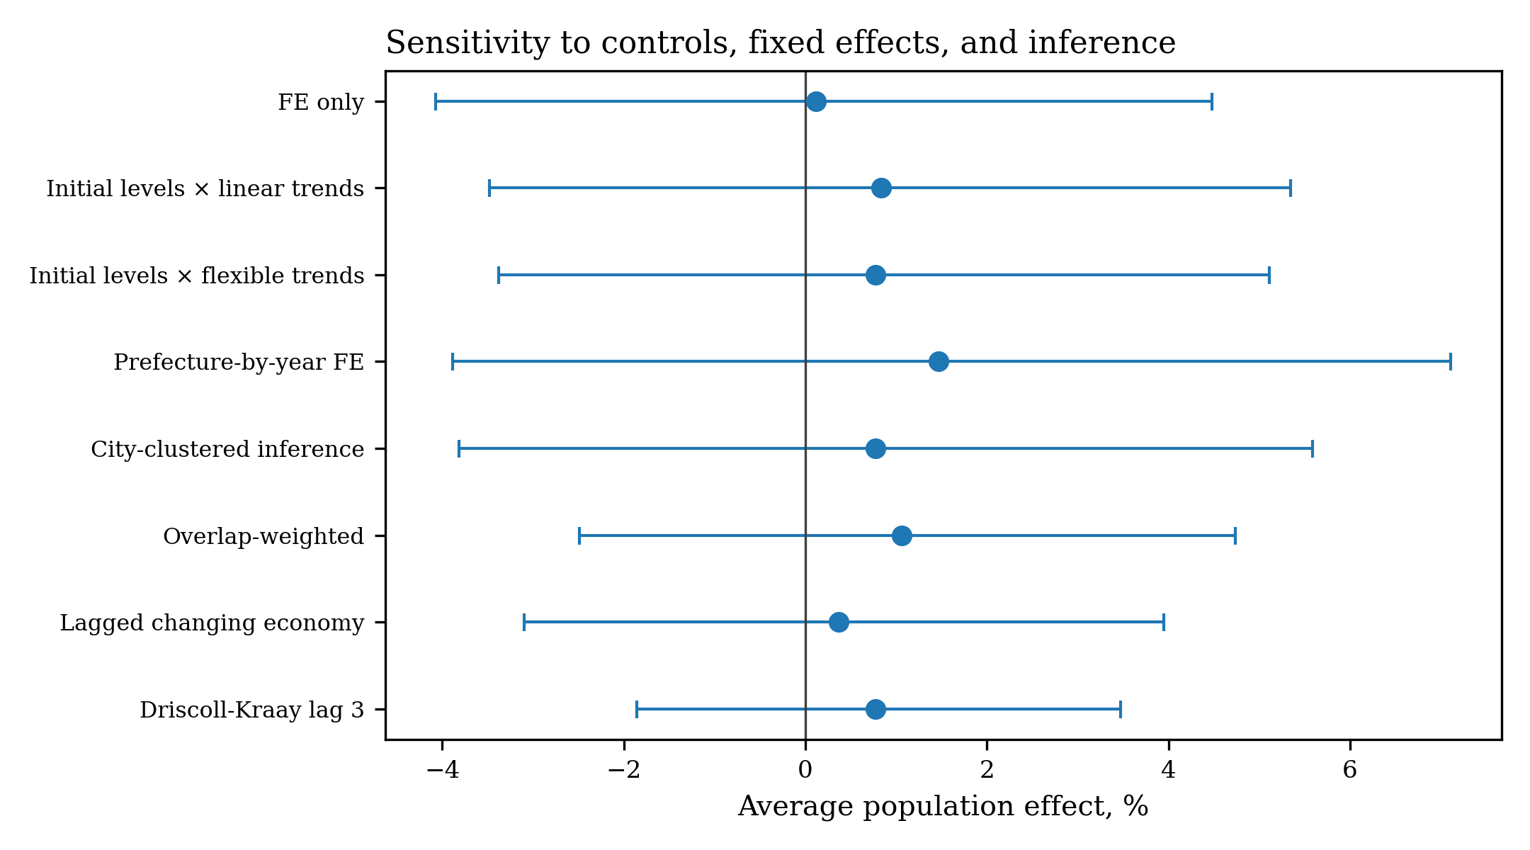
Supplementary Fig. S7. Sensitivity of the static average effect to controls and inference choices. Estimates remain centered near zero across fixed effect structures, baseline trend controls, and covariance choices, showing that the weak pooled average is not an artifact of one particular specification.
Supplementary Table S9. Alternative control structures and stacked fixed effects. These specifications vary the conditioning set and high dimensional fixed effects while preserving the same population outcome, providing a specification based audit of the static result.
model | term | estimate | SE | p | effect_% | CI_low_% | CI_high_%
FE only | active_any | 0.0011 | 0.0218 | 0.9581 | 0.1145 | -4.0699 | 4.4814
Initial levels × linear trends | active_any | 0.0083 | 0.0223 | 0.7085 | 0.8379 | -3.4773 | 5.3461
Initial levels × flexible trends | active_any | 0.0077 | 0.0215 | 0.7196 | 0.7745 | -3.3816 | 5.1094
Prefecture-by-year FE | active_any | 0.0145 | 0.0276 | 0.5988 | 1.4636 | -3.8829 | 7.1076
City-clustered inference | active_any | 0.0077 | 0.0238 | 0.7456 | 0.7745 | -3.8153 | 5.5832
Overlap-weighted | active_any | 0.0106 | 0.0182 | 0.5626 | 1.0615 | -2.4872 | 4.7394
Lagged changing economy | active_any | 0.0036 | 0.0179 | 0.8385 | 0.3656 | -3.0958 | 3.9506
Driscoll-Kraay lag 3 | active_any | 0.0077 | 0.0135 | 0.5675 | 0.7745 | -1.856 | 3.4755

outcome | fixed_effects | estimate | SE | p | effect_% | q_BH | MDE_80pct_power
pop_total | Stack-province-year | 0.0054 | 0.0123 | 0.663 | 0.5371 | 0.663 | 3.5015
pop_total | Stack-prefecture-year | 0.0205 | 0.0216 | 0.3419 | 2.076 | 0.663 | 6.2402
pop_rural | Stack-province-year | -0.0055 | 0.0098 | 0.5756 | -0.5465 | 0.663 | 2.7786
pop_rural | Stack-prefecture-year | -0.012 | 0.0105 | 0.2498 | -1.1975 | 0.663 | 2.9744

D3 Complete specification curve and minimum detectable effects
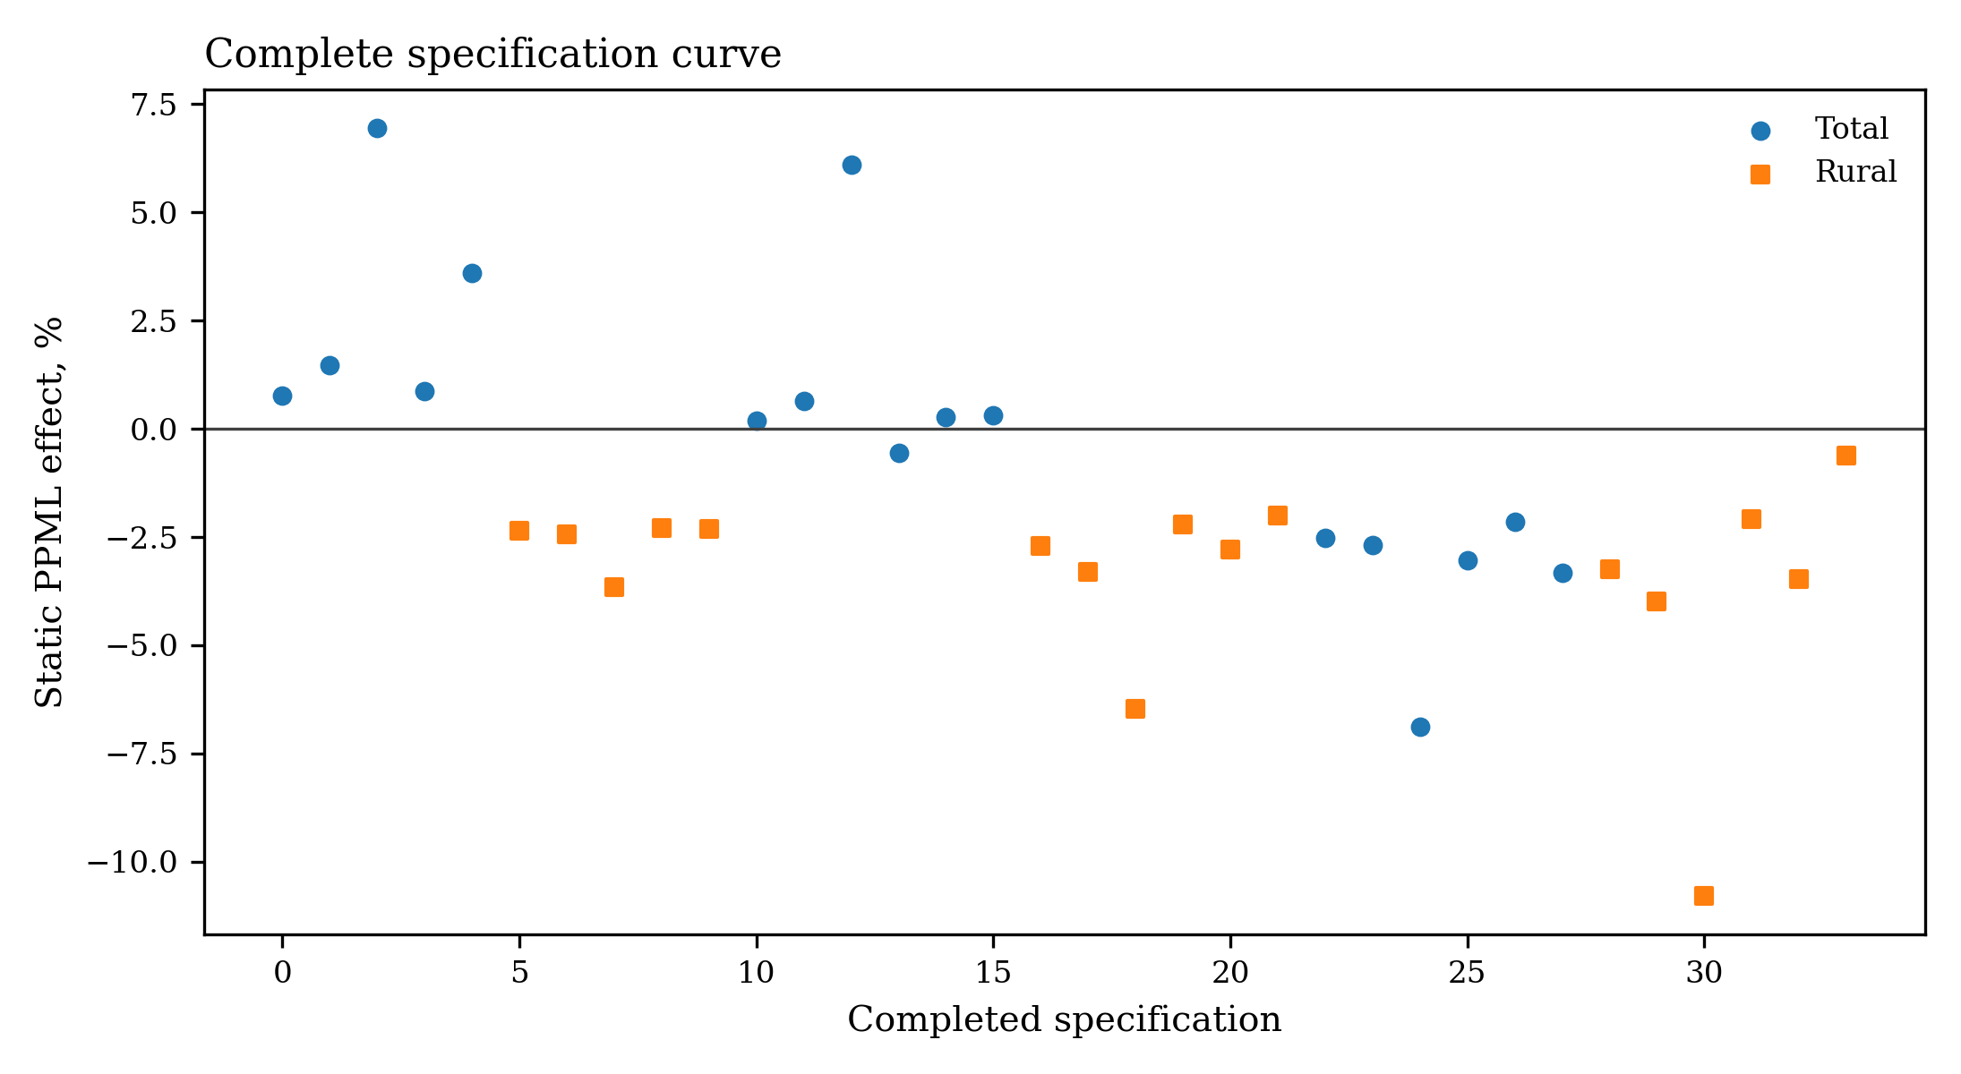
Supplementary Fig. S8. Complete specification curve. The figure plots all completed static PPML specifications across causal cohort thresholds, controls, and fixed effects for total and rural population. The spread quantifies specification sensitivity and shows that no single static specification carries the main short term causal claim.
Supplementary Table S10. Specification curve summary and complete estimates. Approximate 80 percent power minimum detectable effects are reported to distinguish imprecision from evidence of exact zero effects.
outcome | specifications | median_effect_pct | minimum_effect_pct | maximum_effect_pct | raw_p_below_005 | BH_q_below_005 | median_MDE_pct
pop_rural | 17 | -2.6974 | -10.7935 | -0.6113 | 0 | 0 | 7.0794
pop_total | 17 | 0.2775 | -6.8765 | 6.9571 | 0 | 0 | 6.6949

minimum_cohort | outcome | controls | fixed_effects | Effect, % | p value | BH q | MDE, %
2003 | pop_total | Economic baseline trends | Province-year | 0.7745 | 0.7196 | 0.8738 | 6.2014
2003 | pop_total | Economic baseline trends | Prefecture-year | 1.4636 | 0.5988 | 0.813 | 8.0403
2003 | pop_total | Economic baseline trends | County trends and province-year | 6.9571 | 0.4926 | 0.7283 | 31.5841
2003 | pop_total | Economic and population pre-trends | Province-year | 0.8652 | 0.6644 | 0.8367 | 5.7181
2003 | pop_total | Economic and population pre-trends | County trends and province-year | 3.5963 | 0.2189 | 0.5674 | 8.3782
2003 | pop_rural | Economic baseline trends | Province-year | -2.3519 | 0.2359 | 0.5674 | 5.7837
2003 | pop_rural | Economic baseline trends | Prefecture-year | -2.4359 | 0.3004 | 0.5674 | 6.8946
2003 | pop_rural | Economic baseline trends | County trends and province-year | -3.6471 | 0.5386 | 0.7631 | 18.4345
2003 | pop_rural | Economic and population pre-trends | Province-year | -2.3005 | 0.2725 | 0.5674 | 6.118
2003 | pop_rural | Economic and population pre-trends | Prefecture-year | -2.3199 | 0.3325 | 0.5674 | 7.0175
2005 | pop_total | Economic baseline trends | Province-year | 0.1845 | 0.9365 | 0.9365 | 6.6949
2005 | pop_total | Economic baseline trends | Prefecture-year | 0.6501 | 0.8268 | 0.9068 | 8.6455
2005 | pop_total | Economic baseline trends | County trends and province-year | 6.0982 | 0.6217 | 0.813 | 39.9197
2005 | pop_total | Economic and population pre-trends | Province-year | -0.5647 | 0.7625 | 0.894 | 5.3868
2005 | pop_total | Economic and population pre-trends | Prefecture-year | 0.2775 | 0.9058 | 0.9333 | 6.779
2005 | pop_total | Economic and population pre-trends | County trends and province-year | 0.3119 | 0.9033 | 0.9333 | 7.4432
2005 | pop_rural | Economic baseline trends | Province-year | -2.6974 | 0.1959 | 0.5674 | 6.0982
2005 | pop_rural | Economic baseline trends | Prefecture-year | -3.3098 | 0.1961 | 0.5674 | 7.5615
2005 | pop_rural | Economic baseline trends | County trends and province-year | -6.4651 | 0.3126 | 0.5674 | 20.3614
2005 | pop_rural | Economic and population pre-trends | Province-year | -2.2064 | 0.2845 | 0.5674 | 6.0104
2005 | pop_rural | Economic and population pre-trends | Prefecture-year | -2.7829 | 0.2638 | 0.5674 | 7.3285
2005 | pop_rural | Economic and population pre-trends | County trends and province-year | -1.9991 | 0.3803 | 0.5971 | 6.6573
2008 | pop_total | Economic baseline trends | Province-year | -2.528 | 0.1895 | 0.5674 | 5.6165
2008 | pop_total | Economic baseline trends | Prefecture-year | -2.6911 | 0.2116 | 0.5674 | 6.305
2008 | pop_total | Economic baseline trends | County trends and province-year | -6.8765 | 0.3338 | 0.5674 | 22.9242
2008 | pop_total | Economic and population pre-trends | Province-year | -3.0325 | 0.0963 | 0.5674 | 5.3217
2008 | pop_total | Economic and population pre-trends | Prefecture-year | -2.1546 | 0.313 | 0.5674 | 6.2317
2008 | pop_total | Economic and population pre-trends | County trends and province-year | -3.3172 | 0.0918 | 0.5674 | 5.7624
2008 | pop_rural | Economic baseline trends | Province-year | -3.2473 | 0.1738 | 0.5674 | 7.0324
2008 | pop_rural | Economic baseline trends | Prefecture-year | -3.9903 | 0.1605 | 0.5674 | 8.4635
2008 | pop_rural | Economic baseline trends | County trends and province-year | -10.7935 | 0.1312 | 0.5674 | 23.597
2008 | pop_rural | Economic and population pre-trends | Province-year | -2.094 | 0.3863 | 0.5971 | 7.0794
2008 | pop_rural | Economic and population pre-trends | Prefecture-year | -3.4611 | 0.2018 | 0.5674 | 8.0326
2008 | pop_rural | Economic and population pre-trends | County trends and province-year | -0.6113 | 0.8235 | 0.9068 | 8.003

D4 Wild cluster bootstrap and small cluster inference
Supplementary Table S11. Wild cluster bootstrap sensitivity for selected short term effects. The small cluster p values are reported alongside the main cluster robust inference to show where limited effective cluster counts materially reduce precision, especially for the rural income impulse.
horizon | outcome | term | observations | wild_t | wild_p
0 | pop_total | treated_group | 2567 | -1.3908 | 0.1812
2 | pop_total | treated_group | 2567 | -1.6139 | 0.0891
0 | rural_income | treated_group:base_rural_share_z | 1380 | -4.1904 | 0.0541
1 | rural_income | treated_group:base_rural_share_z | 1350 | -1.1312 | 0.5756

D5 Leave one province out sensitivity
Supplementary Table S12. Leave one province out static PPML estimates. Removing each coastal province or municipality in turn leaves the average post establishment estimate near zero, which indicates that the pooled static result is not driven by one province.
Excluded region | Effect, % | CI low, % | CI high, % | p value
Shanghai | -1.1048 | -4.3954 | 2.299 | 0.5199
Tianjin | 0.6845 | -3.3259 | 4.8614 | 0.7422
Shandong | 2.448 | -2.5372 | 7.6882 | 0.342
Guangdong | -0.9236 | -5.7385 | 4.1373 | 0.7151
Guangxi | 0.8931 | -3.2534 | 5.2174 | 0.6779
Jiangsu | 0.9151 | -3.5591 | 5.5969 | 0.6938
Hebei | 1.9093 | -2.3501 | 6.3544 | 0.3853
Zhejiang | 1.1726 | -3.7616 | 6.3597 | 0.6477
Hainan | 0.7745 | -3.3816 | 5.1094 | 0.7196
Fujian | 0.9154 | -3.4882 | 5.5199 | 0.689
Liaoning | 0.469 | -3.944 | 5.0847 | 0.8382

D6 Residual spatial dependence and randomized timing placebo
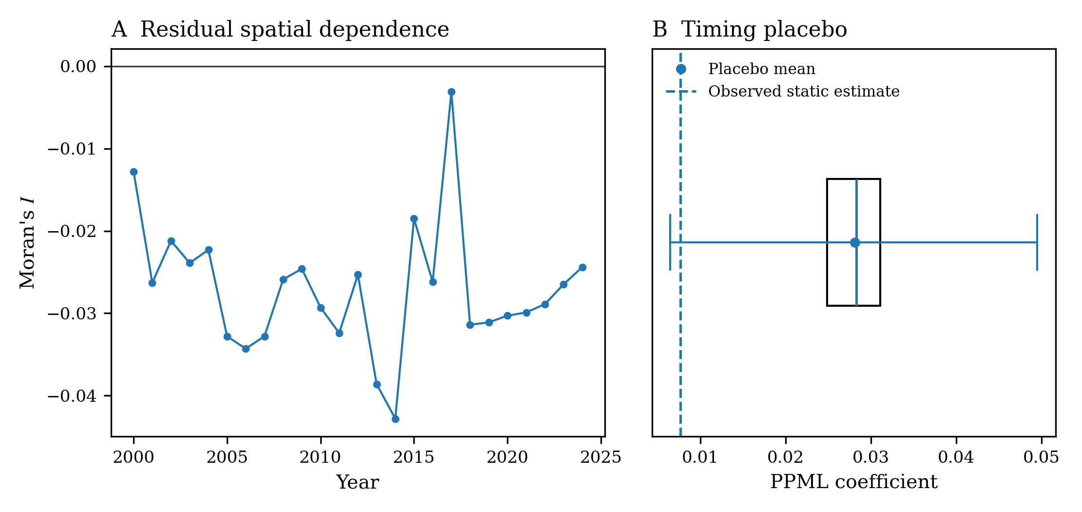
Supplementary Fig. S10. Residual spatial dependence and randomized adoption year placebo from the executed notebook. The left panel reports annual Moran's I statistics for PPML residuals under the direct plus nearby exposure model. The right panel reconstructs the executed 50 repetition placebo distribution from its minimum, quartiles, median, mean, and maximum and compares that distribution with the observed static coefficient. These diagnostics assess remaining spatial structure and mechanical timing sensitivity for the pooled specification.
Supplementary Table S13. Annual residual Moran statistics and randomized timing placebo summary. The Moran table reports the permutation p value and county count for each year, while the placebo summary records the distribution of randomized adoption year coefficients.
Year | Moran's I | Permutation p value | Counties
2000.0 | -0.0128 | 0.314 | 280.0
2001.0 | -0.0263 | 0.088 | 280.0
2002.0 | -0.0212 | 0.15 | 280.0
2003.0 | -0.0239 | 0.118 | 280.0
2004.0 | -0.0223 | 0.11 | 280.0
2005.0 | -0.0328 | 0.034 | 280.0
2006.0 | -0.0343 | 0.03 | 280.0
2007.0 | -0.0328 | 0.028 | 280.0
2008.0 | -0.0259 | 0.096 | 280.0
2009.0 | -0.0246 | 0.082 | 280.0
2010.0 | -0.0293 | 0.05 | 280.0
2011.0 | -0.0324 | 0.042 | 280.0
2012.0 | -0.0253 | 0.058 | 280.0
2013.0 | -0.0386 | 0.016 | 280.0
2014.0 | -0.0428 | 0.004 | 280.0
2015.0 | -0.0185 | 0.212 | 280.0
2016.0 | -0.0262 | 0.06 | 280.0
2017.0 | -0.0031 | 0.456 | 280.0
2018.0 | -0.0314 | 0.044 | 280.0
2019.0 | -0.0311 | 0.044 | 280.0
2020.0 | -0.0303 | 0.068 | 280.0
2021.0 | -0.0299 | 0.046 | 280.0
2022.0 | -0.0289 | 0.066 | 280.0
2023.0 | -0.0265 | 0.09 | 280.0
2024.0 | -0.0244 | 0.102 | 280.0

statistic | count | mean | std | min | 25% | 50% | 75% | max
placebo_coefficient | 50.0 | 0.0281 | 0.0078 | 0.0065 | 0.0249 | 0.0283 | 0.0311 | 0.0495

Supplementary E Alternative treatment definitions and population outcomes
E1 Protected area area allocation and spatial radius sensitivity
Supplementary Table S14. Alternative protected area area allocation and spatial exposure radii. Equal share and full area assignment produce similar static conclusions, and the nearby exposure models show how point estimates vary across spatial bandwidths. These checks test whether results are created by one arbitrary exposure mapping rule.
model | term | estimate | SE | p | effect_% | CI_low_% | CI_high_%
Equal-share allocated area | ln1p_mpa_area_alloc | 0.0026 | 0.0043 | 0.549 | 0.2587 | -0.585 | 1.1095
Full area assigned to every linked county | ln1p_mpa_area_full | 0.0016 | 0.0031 | 0.6145 | 0.1575 | -0.4541 | 0.7729

model | term | estimate | SE | p | effect_% | CI_low_% | CI_high_%
100 km | active_any | 0.0052 | 0.0224 | 0.8148 | 0.5262 | -3.7928 | 5.0391
100 km | spill_r100 | 0.0141 | 0.0198 | 0.4757 | 1.4229 | -2.4397 | 5.4384
200 km | active_any | 0.0077 | 0.0218 | 0.7256 | 0.7694 | -3.453 | 5.1765
200 km | spill_r200 | 0.0011 | 0.0325 | 0.9731 | 0.1098 | -6.0698 | 6.696
300 km | active_any | 0.0078 | 0.0215 | 0.719 | 0.7782 | -3.3889 | 5.1249
300 km | spill_r300 | -0.0026 | 0.0431 | 0.9521 | -0.2586 | -8.3356 | 8.5301

E2 Extended population outcomes
Supplementary Table S15. Extended county population outcomes. Rural population, rural population share, and annual population growth provide complementary demographic measures. Their weaker pooled estimates support the paper's decision to define the primary estimand as short term adjustment in total population levels.
model | term | estimate | SE | p | effect_% | CI_low_% | CI_high_% | block | t value | ci_low | ci_high
Total population | active_any | 0.0077 | 0.0215 | 0.7196 | 0.7745 | -3.3816 | 5.1094 | Population level
Rural population | active_any | -0.0238 | 0.0201 | 0.2359 | -2.3519 | -6.1205 | 1.5679 | Population level
Population density rate | active_any | -0.0195 | 0.0268 | 0.4658 | -1.9327 | -6.9437 | 3.3482 | Population level
Rural population share | active_any | -0.0193 | 0.0126 | 0.1265 |  |  |  | Rural share | -1.5325 | -0.0441 | 0.0055
Annual population growth, percentage points | active_any | -0.1274 | 0.2502 | 0.6109 |  |  |  | Growth rate | -0.5094 | -0.62 | 0.3651

E3 Prefecture population sensitivity
Supplementary Table S16. Prefecture resident population sensitivities using city database measures. Because original observation coverage is limited for city resident population, these models are treated as supplementary to the preferred prefecture aggregate constructed from county population.
model | term | estimate | SE | p | effect_% | CI_low_% | CI_high_%
City MPA site count | ln1p_mpa_sites | -0.024 | 0.02 | 0.2298 | -2.3728 | -6.1251 | 1.5295
City MPA area | ln1p_mpa_area | -0.0041 | 0.0024 | 0.0853 | -0.407 | -0.8686 | 0.0568

Supplementary F Livelihood heterogeneity and mechanism extensions
F1 Rural dependence interactions and marginal effects
Supplementary Table S17. Rural dependence interaction models and recentered marginal effects. The clean control interaction is statistically strong, while event interactions reveal a pre existing structural component. The table therefore supports effect heterogeneity while cautioning against interpreting rural dependence as a separately identified mediator.
outcome | exposure | Effect | CI low | CI high | p value | BH q | FDR_significant
pop_total | Binary establishment | -5.7763 | -11.0704 | -0.167 | 0.0437 | 0.0936 | False
pop_total | Allocated area | -0.9825 | -1.9762 | 0.0213 | 0.055 | 0.0963 | False
pop_total | Site count | -5.2096 | -12.9375 | 3.2044 | 0.2176 | 0.2381 | False
pop_total | National-level count | -6.8539 | -14.9872 | 2.0575 | 0.1277 | 0.1626 | False
pop_total | Nature-reserve count | -11.752 | -19.3399 | -3.4503 | 0.0064 | 0.03 | True
pop_rural | Binary establishment | 6.5614 | -0.8611 | 14.5396 | 0.0845 | 0.1314 | False
pop_rural | Allocated area | 1.2262 | 0.0231 | 2.4438 | 0.0457 | 0.0936 | False
pop_rural | Site count | 9.256 | 0.1261 | 19.2184 | 0.0468 | 0.0936 | False
pop_rural | National-level count | 10.5207 | 1.1783 | 20.7257 | 0.0264 | 0.0925 | False
pop_rural | Nature-reserve count | 6.9191 | -1.5941 | 16.1688 | 0.114 | 0.1596 | False
pop_total | Binary establishment | -5.0061 | -7.6375 | -2.2997 | 0.0003 | 0.0048 | True
pop_total | Binary establishment | -4.9226 | -7.6549 | -2.1094 | 0.0007 | 0.0048 | True
pop_rural | Binary establishment | -1.1931 | -3.0745 | 0.7248 | 0.2211 | 0.2381 | False
pop_rural | Binary establishment | 1.3779 | -1.5526 | 4.3956 | 0.3605 | 0.3605 | False

interaction | rurality_z | Effect | CI low | CI high | p value | BH q | FDR_significant
Clean-control binary MPA | -1.0 | 6.1048 | 1.8303 | 10.5587 | 0.0047 | 0.0095 | True
Nature-reserve intensity | -1.0 | 21.6299 | 8.1317 | 36.813 | 0.0011 | 0.0066 | True
Clean-control binary MPA | 0.0 | 0.8817 | -1.06 | 2.8616 | 0.376 | 0.4169 | False
Nature-reserve intensity | 0.0 | 7.3359 | -1.514 | 16.981 | 0.1069 | 0.1603 | False
Clean-control binary MPA | 1.0 | -4.0842 | -6.7011 | -1.394 | 0.0031 | 0.0094 | True
Nature-reserve intensity | 1.0 | -5.2783 | -16.901 | 7.9702 | 0.4169 | 0.4169 | False

F2 Full event interaction diagnostics
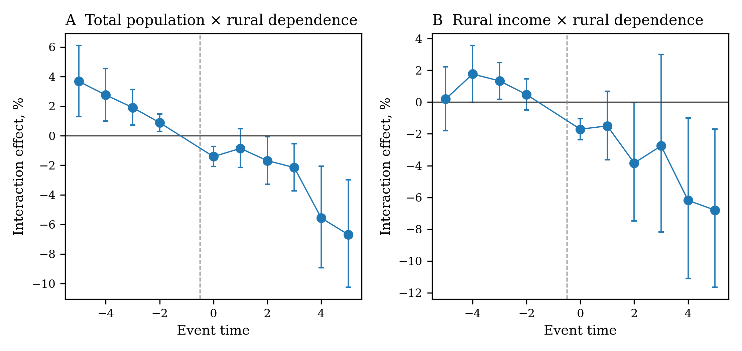
Supplementary Fig. S9. Full rural dependence event interactions for total population and observed year rural income. The population interaction shows pre establishment structural divergence, while the rural income interaction has a cleaner pretreatment profile and several FDR significant post treatment periods. This contrast explains why income is treated as stronger supporting livelihood evidence than the population interaction itself.
Supplementary Table S18. Complete rural dependence event interactions and trend break diagnostics. BH q values are reported separately within pretreatment and post treatment families so the timing of significant interaction terms remains transparent.
outcome | event_time | Effect, % | CI low, % | CI high, % | p value | BH q | FDR_significant
Total population | -5 | 3.6783 | 1.2989 | 6.1135 | 0.0023 | 0.003 | True
Total population | -4 | 2.7585 | 1.0036 | 4.5439 | 0.002 | 0.003 | True
Total population | -3 | 1.9092 | 0.7153 | 3.1172 | 0.0017 | 0.003 | True
Total population | -2 | 0.8889 | 0.3012 | 1.48 | 0.003 | 0.003 | True
Total population | 0 | -1.4118 | -2.089 | -0.73 | 0.0001 | 0.0003 | True
Total population | 1 | -0.8543 | -2.1567 | 0.4654 | 0.2035 | 0.2035 | False
Total population | 2 | -1.6868 | -3.2867 | -0.0604 | 0.0421 | 0.0506 | False
Total population | 3 | -2.1514 | -3.7383 | -0.5384 | 0.0091 | 0.0137 | True
Total population | 4 | -5.5625 | -8.944 | -2.0555 | 0.0021 | 0.0042 | True
Total population | 5 | -6.685 | -10.2358 | -2.9937 | 0.0005 | 0.0014 | True
Rural disposable income, original-observation years | -5 | 0.1943 | -1.7942 | 2.2231 | 0.8494 | 0.8494 | False
Rural disposable income, original-observation years | -4 | 1.7656 | -0.0057 | 3.5683 | 0.0507 | 0.1015 | False
Rural disposable income, original-observation years | -3 | 1.3347 | 0.1836 | 2.4989 | 0.0229 | 0.0917 | False
Rural disposable income, original-observation years | -2 | 0.4766 | -0.504 | 1.4669 | 0.342 | 0.456 | False
Rural disposable income, original-observation years | 0 | -1.7066 | -2.3726 | -1.036 | 0.0 | 0.0 | True
Rural disposable income, original-observation years | 1 | -1.4967 | -3.6266 | 0.6804 | 0.1764 | 0.2116 | False
Rural disposable income, original-observation years | 2 | -3.834 | -7.4902 | -0.0333 | 0.0481 | 0.0721 | False
Rural disposable income, original-observation years | 3 | -2.7528 | -8.1765 | 2.9912 | 0.3404 | 0.3404 | False
Rural disposable income, original-observation years | 4 | -6.1863 | -11.1039 | -0.9966 | 0.0201 | 0.0402 | True
Rural disposable income, original-observation years | 5 | -6.7976 | -11.6356 | -1.6948 | 0.0096 | 0.0289 | True

outcome | term | estimate | SE | p | ci_low | ci_high | effect | effect_low | effect_high | unit | q_BH_family
Total population | stack_post:base_rural_share_z | 0.0179 | 0.0064 | 0.005 | 0.0054 | 0.0304 | 1.8056 | 0.5423 | 3.0848 | percent | 0.0099
Total population | post_time:base_rural_share_z | 0.0254 | 0.0076 | 0.0008 | 0.0105 | 0.0403 | 2.5712 | 1.0553 | 4.1098 | percent | 0.0033
Rural disposable income, original-observation years | stack_post:base_rural_share_z | -0.0038 | 0.0108 | 0.729 | -0.025 | 0.0175 | -0.375 | -2.4701 | 1.7652 | percent | 0.729
Rural disposable income, original-observation years | post_time:base_rural_share_z | 0.0133 | 0.0117 | 0.2566 | -0.0097 | 0.0362 | 1.3372 | -0.9619 | 3.6897 | percent | 0.3421

F3 Rural income, employment, service, tourism, and environmental outcomes
Supplementary Table S19. County livelihood and service outcomes. The table reports full and original observation samples together with multiplicity adjusted significance. Rural disposable income provides the clearest supporting livelihood signal, while service and employment outcomes are more variable.
family | sample | outcome | observations | Effect | CI low | CI high | p value | BH q | FDR_significant
Attraction and services | Full ARIMA sheet | Tertiary GDP share | 28237 | -2.7434 | -7.0499 | 1.563 | 0.2108 | 0.3162 | False
Attraction and services | Original-observation years | Tertiary GDP share | 19148 | -1.8876 | -5.6469 | 1.8716 | 0.3235 | 0.8839 | False
Attraction and services | Full ARIMA sheet | Tertiary-sector unit jobs | 28237 | 7.0012 | -0.5703 | 15.1492 | 0.0707 | 0.2122 | False
Attraction and services | Original-observation years | Tertiary-sector unit jobs | 6364 | 4.9441 | -41.5932 | 88.5611 | 0.8718 | 0.8839 | False
Attraction and services | Full ARIMA sheet | Retail sales | 28237 | 1.0104 | -3.8189 | 6.0822 | 0.6875 | 0.6875 | False
Attraction and services | Original-observation years | Retail sales | 19836 | 0.3383 | -4.1088 | 4.9916 | 0.8839 | 0.8839 | False
Rural economic adjustment | Full ARIMA sheet | Rural disposable income | 28237 | -7.4508 | -12.9296 | -1.6274 | 0.0129 | 0.0387 | True
Rural economic adjustment | Original-observation years | Rural disposable income | 15447 | -2.8951 | -4.429 | -1.3366 | 0.0003 | 0.0009 | True
Rural economic adjustment | Full ARIMA sheet | Rural employment | 28237 | -0.2702 | -3.256 | 2.8077 | 0.8615 | 0.8615 | False
Rural economic adjustment | Original-observation years | Rural employment | 11438 | 5.4063 | -0.9806 | 12.2052 | 0.0987 | 0.1481 | False
Rural economic adjustment | Full ARIMA sheet | Primary GDP share | 28237 | -5.8925 | -13.793 | 2.008 | 0.1432 | 0.2147 | False
Rural economic adjustment | Original-observation years | Primary GDP share | 17960 | 0.4628 | -0.6143 | 1.5398 | 0.398 | 0.398 | False

Supplementary Table S20. Prefecture service, tourism, population corroboration, and environmental proxy outcomes. Most service and environmental proxies remain imprecise after multiplicity adjustment and therefore do not enter the main mechanism argument.
family | outcome | observations | original_observation_share | Effect | CI low | CI high | p value | BH q | FDR_significant
Population corroboration | Resident population | 2937 | 0.1183 | -4.475 | -8.6818 | -0.0743 | 0.0463 | 0.0463 | True
Tourism and services | Tertiary GDP share | 2937 | 0.9419 | -1.7786 | -4.9442 | 1.387 | 0.2663 | 0.5367 | False
Tourism and services | Tertiary employment share | 2937 | 0.7843 | -2.0919 | -7.3488 | 3.1651 | 0.4301 | 0.5376 | False
Tourism and services | Accommodation and catering jobs | 2937 | 0.6699 | 12.4063 | -63.3222 | 244.4907 | 0.8378 | 0.8378 | False
Tourism and services | Passenger volume | 2937 | 0.5861 | 21.9058 | -10.8877 | 66.7673 | 0.2154 | 0.5367 | False
Tourism and services | Retail sales | 2937 | 0.9854 | 2.8969 | -2.7572 | 8.8798 | 0.322 | 0.5367 | False
Environmental quality | PM2.5 concentration | 2937 | 0.2953 | 1.7347 | -0.4407 | 3.91 | 0.1163 | 0.1812 | False
Environmental quality | Sewage treatment rate | 2937 | 0.3183 | -3.3949 | -29.0753 | 22.2855 | 0.7928 | 0.7928 | False
Environmental quality | Waste harmless-treatment rate | 2937 | 0.8581 | 18.3271 | -4.9446 | 41.5987 | 0.1208 | 0.1812 | False

F4 Protection type heterogeneity
Supplementary Table S21. Protection type and rural dependence extensions. Nature reserve, marine park, and other protection type models examine whether the local livelihood gradient differs across protection forms. These estimates are exploratory because protection type also covaries with timing, intensity, and management practice.
family | outcome | exposure | observations | Effect | CI low | CI high | p value | BH q | FDR_significant
Attraction by protection type | Tertiary GDP share | ln1p_special_sites | 7025 | -2.6499 | -9.9537 | 4.6538 | 0.4757 | 0.4848 | False
Attraction by protection type | Tertiary GDP share | ln1p_park_sites | 7025 | 7.2504 | -0.9526 | 15.4535 | 0.083 | 0.1245 | False
Attraction by protection type | Tertiary-sector unit jobs | ln1p_special_sites | 7025 | -28.821 | -48.1967 | -2.1982 | 0.036 | 0.0826 | False
Attraction by protection type | Tertiary-sector unit jobs | ln1p_park_sites | 7025 | 68.2534 | 20.8076 | 134.333 | 0.0021 | 0.0125 | True
Attraction by protection type | Retail sales | ln1p_special_sites | 7025 | 13.2459 | 0.4908 | 27.62 | 0.0413 | 0.0826 | False
Attraction by protection type | Retail sales | ln1p_park_sites | 7025 | 8.3257 | -13.4473 | 35.5758 | 0.4848 | 0.4848 | False
Resource adjustment by protection type | Rural disposable income | ln1p_nature_sites | 7025 | -13.3896 | -38.7367 | 22.4446 | 0.4158 | 0.6093 | False
Resource adjustment by protection type | Rural disposable income | ln1p_germplasm_sites | 7025 | -6.1131 | -22.7649 | 14.1289 | 0.5266 | 0.6093 | False
Resource adjustment by protection type | Rural employment | ln1p_nature_sites | 7025 | 2.8077 | -3.3928 | 9.4062 | 0.383 | 0.6093 | False
Resource adjustment by protection type | Rural employment | ln1p_germplasm_sites | 7025 | 3.8598 | -10.1802 | 20.0944 | 0.6093 | 0.6093 | False
Resource adjustment by protection type | Primary GDP share | ln1p_nature_sites | 7025 | -2.0703 | -7.2873 | 3.1467 | 0.4354 | 0.6093 | False
Resource adjustment by protection type | Primary GDP share | ln1p_germplasm_sites | 7025 | -6.1927 | -20.4182 | 8.0329 | 0.3922 | 0.6093 | False
Population by protection type | Total population | ln1p_nature_sites | 7025 | -11.4646 | -18.9971 | -3.2316 | 0.0073 | 0.0291 | True
Population by protection type | Total population | ln1p_germplasm_sites | 7025 | -1.4913 | -10.4079 | 8.3128 | 0.7563 | 0.7563 | False
Population by protection type | Total population | ln1p_special_sites | 7025 | 9.8479 | -2.9527 | 24.337 | 0.1373 | 0.2746 | False
Population by protection type | Total population | ln1p_park_sites | 7025 | 2.9371 | -6.3793 | 13.1806 | 0.5498 | 0.7331 | False

contrast | rurality_z | estimate | SE | p | ci_low | ci_high | effect | effect_low | effect_high | unit | q_BH_family
Nature-reserve population | -1.0 | 0.2009 | 0.0597 | 0.0008 | 0.0838 | 0.318 | 22.2511 | 8.7424 | 37.438 | percent | 0.0031
Nature-reserve population | 1.0 | -0.0426 | 0.0653 | 0.5141 | -0.1707 | 0.0854 | -4.1732 | -15.6914 | 8.9186 | percent | 0.5141
Marine-park tertiary jobs | -1.0 | -0.7256 | 0.2558 | 0.0046 | -1.2269 | -0.2242 | -51.5949 | -70.6809 | -20.0842 | percent | 0.0091
Marine-park tertiary jobs | 1.0 | 0.315 | 0.1654 | 0.0568 | -0.0092 | 0.6392 | 37.0311 | -0.9128 | 89.505 | percent | 0.0758

Supplementary G Spatial exposure and scale extensions
G1 Nearby MPA exposure and lead negative control
Supplementary Table S22. Nearby protection exposure and temporal negative control. The contemporaneous nearby site interaction along the rural dependence gradient is negative with p about 0.045, while the one year lead is imprecise. The contrast supports temporal ordering while remaining a secondary spatial channel.
exposure | term | observations | estimate | SE | p | ci_low | ci_high | effect | effect_low | effect_high | unit
spill_site_exposure | current | 6463 | -0.0074 | 0.0037 | 0.0452 | -0.0146 | -0.0002 | -0.7369 | -1.4528 | -0.0158 | percent
spill_site_exposure | one-year lead placebo | 6463 | 0.0032 | 0.004 | 0.423 | -0.0046 | 0.0109 | 0.3175 | -0.4596 | 1.1007 | percent
spill_area_exposure | current | 6463 | -0.0008 | 0.0006 | 0.1598 | -0.002 | 0.0003 | -0.0814 | -0.1949 | 0.0323 | percent
spill_area_exposure | one-year lead placebo | 6463 | 0.0001 | 0.0006 | 0.8742 | -0.0012 | 0.0014 | 0.0101 | -0.1156 | 0.136 | percent

Supplementary Table S23. Nearby MPA stock interactions. Site and allocated area exposure measures test whether protection conditions outside the focal county boundary contribute to population adjustment.
outcome | exposure | estimate | SE | p | ci_low | ci_high | effect | effect_low | effect_high | unit | q_BH_family | FDR_significant
pop_total | Nearby site stock | 0.0486 | 0.0553 | 0.3798 | -0.0599 | 0.1571 | 4.98 | -5.8099 | 17.0061 | percent | 0.7596 | False
pop_total | Nearby allocated area | 0.0137 | 0.0268 | 0.608 | -0.0387 | 0.0662 | 1.3823 | -3.7991 | 6.8427 | percent | 0.8107 | False
pop_rural | Nearby site stock | 0.0289 | 0.1342 | 0.8295 | -0.2341 | 0.2918 | 2.9317 | -20.8681 | 33.8895 | percent | 0.8295 | False
pop_rural | Nearby allocated area | 0.0839 | 0.0236 | 0.0004 | 0.0376 | 0.1302 | 8.7536 | 3.8308 | 13.9097 | percent | 0.0015 | True

G2 Within prefecture receiving county test
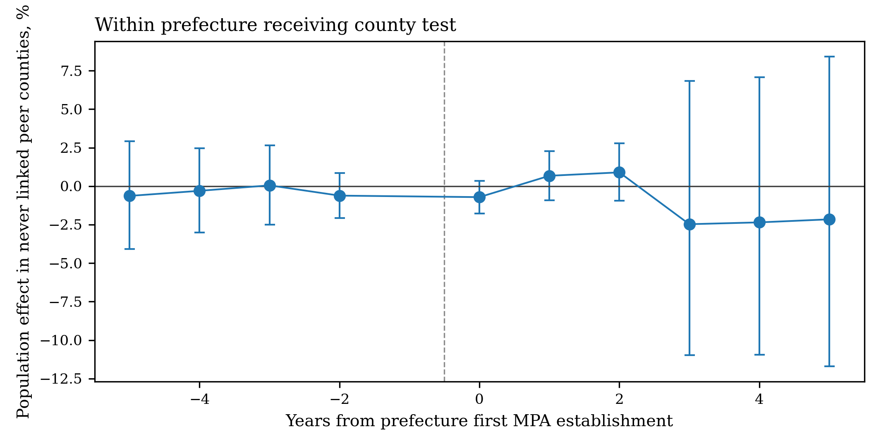
Supplementary Fig. S11. Event study for counties never directly linked to an MPA within treated prefectures. Estimates from five years before through five years after prefecture treatment remain imprecise and do not show a systematic post establishment increase. The result supports the main text statement that a detectable receiving county response is not observed. The displayed dynamic window is event time −5 through +5 with −1 omitted, matching the common level event study reporting convention.
Supplementary Table S24. Within prefecture scale comparison. The fixed set of counties ever linked to an MPA contracts substantially, while the prefecture aggregate and never linked peer county estimates are much smaller and imprecise. The comparison documents attenuation as population is aggregated to broader administrative scales.
outcome | estimate | std_error | t_value | cluster_df | p_value | percent_effect | percent_ci_low | percent_ci_high | observations | prefectures | converged
Never-treated peer counties | -0.0087537570372799 | 0.0275946616436184 | -0.3172264675803468 | 8 | 0.7591926959611411 | -0.8715554459443405 | -6.982929963383001 | 5.64134643069512 | 209 | 9 | True
All counties in prefecture | -0.0192620435653769 | 0.0173562806105733 | -1.1098024972955678 | 8 | 0.2993265984232028 | -1.9077715811254337 | -5.756252221230929 | 2.0978632849774623 | 209 | 9 | True
Ever-MPA-linked counties, fixed set | -0.144397736667084 | 0.0303556196289821 | -4.756870010626297 | 6 | 0.0031364668029394 | -13.445657876753549 | -19.641737046580538 | -6.771825758222104 | 121 | 7 | True

Supplementary Table S25. Complete never linked peer county event study. BH adjusted q values are included for the full event window so the absence of a detectable receiving county increase is evaluated as a family of dynamic estimates.
event_time | estimate | std_error | t_value | cluster_df | p_value | percent_effect | percent_ci_low | percent_ci_high | q_BH
-5 | -0.0063640545073186 | 0.0152831396701025 | -0.4164101516240293 | 8 | 0.6880574404953375 | -0.6343846802801619 | -4.075334579140366 | 2.9299968318624003 | 0.8600718006191719
-4 | -0.0030503235828025 | 0.0118905222724825 | -0.2565340287753108 | 8 | 0.8040124301430011 | -0.3045676072493714 | -3.001038828370313 | 2.4668627367169145 | 0.8933471446033345
-3 | 0.0005081574844215 | 0.0111697436940935 | 0.0454941042819282 | 8 | 0.9648285973109788 | 0.0508286618308567 | -2.4933219650185228 | 2.661361433396261 | 0.9648285973109788
-2 | -0.0061764321536322 | 0.0063818601007391 | -0.9678106470740232 | 8 | 0.3614829482360606 | -0.6157397206074622 | -2.067628075420665 | 0.8576734860337571 | 0.8600718006191719
0 | -0.0071721392128506 | 0.0046325749934266 | -1.5481971091730882 | 8 | 0.1601652525022681 | -0.7146480800952306 | -1.7696422459854415 | 0.3516767244642502 | 0.8600718006191719
1 | 0.0067081654648966 | 0.0068586786269035 | 0.9780550787995076 | 8 | 0.35669294880734 | 0.6730715601999218 | -0.9066623838578542 | 2.277989430786388 | 0.8600718006191719
2 | 0.0089027637806214 | 0.0080162701006501 | 1.1105868026951098 | 8 | 0.2990082890052651 | 0.8942511248632734 | -0.953701961896423 | 2.776682336282911 | 0.8600718006191719
3 | -0.0250333960206072 | 0.0395552682934245 | -0.6328713493966781 | 8 | 0.5444791386089494 | -2.472265889771515 | -10.97455945425551 | 6.842031472879831 | 0.8600718006191719
4 | -0.0238159487002697 | 0.0400011530990736 | -0.595381554158779 | 8 | 0.5680444763716741 | -2.353458705150607 | -10.957711120705984 | 7.082231901879732 | 0.8600718006191719
5 | -0.0218005199445331 | 0.0444800066322338 | -0.4901195299897883 | 8 | 0.6372073129513511 | -2.156460606793698 | -11.694836135139614 | 8.412212627119956 | 0.8600718006191719

Supplementary H Reproducibility record
The executable notebook accompanying these Supplementary Materials contains the complete data harmonization, MPA exposure reconstruction, causal sample formation, overlap weighting, PPMLHDFE estimation, local projection DID, cohort robust and clean control event studies, first difference diagnostics, rural dependence interactions, mechanism analyses, spatial exposure models, Moran diagnostics, leave one province out checks, randomized treatment timing placebo, within prefecture scale analysis, and generation of every main text and supplementary figure and table. The notebook preserves the executed outputs from the analysis run and appends the final publication figure and Supplementary export code.
Supplementary Table S26. Recorded analysis environment. Package versions and the fixed random seed identify the executed computational environment used to create the archived results.
component | version
Python | 3.12.13
pandas | 3.0.5
numpy | 2.5.3
pyfixest | 0.60.0
libpysal | 4.15.0
esda | 2.10.0
platform | Linux-6.18.35-x86_64-with-glibc2.39
random seed | 20260907

